BFS Domain Consulting Group
Trade Matching and Messaging
Process - IT Model
Version 0.2



Last Updated: 22nd December 2006

Cognizant Technology Solutions US Corporation
500, Glenpointe Center West
Teaneck, NJ 07666
www.cognizant.com
The information contained in this document is confidential and intended for the named recipient only. This information is the sole property of “Cognizant“, duplication or disclosure by any other person is strictly prohibited. If you have received this documentation by mistake, please notify sender immediately.
The information contained in this document is confidential and intended for the named recipient only. This information is the sole property of “Cognizant“, duplication or disclosure by any other person is strictly prohibited. If you have received this documentation by mistake, please notify sender immediately.

Document Revision History
# | Description | Date | Version | Created / Modified By
1 | Original Version | 22/12/2006 | 0.1 | Bala, Harini, Girish, Kamakhya
2 | Review comments of DCG and Technical team incorporated | 23/01/2007 | 0.2 | Bala, Girish, Harini
Table of Contents
1. Introduction 5
1.1 Purpose of the Document 7
1.2 Scope of the Document 7
1.3 Audience 7
1.4 Abbreviation and description 7
2. Industry Overview 8
2.3 Key Entities 8
2.4 Business Entity Interaction Diagram 9
2.5 Key Definitions 10
2.6 Organization View 11
2.7 Industry Processes 15
2.8 Business Models 19
3. Process Overview 22
3.1 Process Diagram 22
3.2 Key Business Processes 23
4. Process Model 32
4.1 Eco System 32
4.2 Use Case View 35
4.3 Use Case Description 38
4.4 Business Scenario Mapping 56
5. IT Model 59
5.1 Functional View 59
5.2 Entity Relationship View 65
5.3 Data View 67
5.4 System View 74
6. Appendix 75
6.1 Appendix–1: References 75
6.2 Appendix–2: Definitions 75
6.3 Appendix–3: SWIFT Messages applicable for trade matching and messaging 77
6.4 Appendix–4: Considerations for a buy vs. build decision 79
6.5 Appendix–5: Sample file for ER Diagram 80
6.6 Appendix–6: Trade Communication Products 81

Introduction
Investment Managers (IM) are professional entities which undertake the management of money for their various clients which can range from the retail investors to the large institutions in exchange for a fee. They are highly regulated entities and they are under constant scrutiny from their account holders. They face an array of challenges from changing regulatory requirements and the need for adoption and implementation of the industry best practices, to ever increasing demands for better returns with the least amount of risk and hence they now dealing with a large basket of financial instruments that differ widely in their characteristics.
An Investment Manager as part of his day to day activities in managing the investments places trading orders across asset classes like equities, bonds, derivatives, FX etc. There trade orders are generally routed through a broker who then forwards it to the trading platforms(stock exchanges etc).Once the trade is executed the broker then notifies the investment manager of an agreed-upon trade by providing a notice of execution(NOE).The investment manager must then verify the trade details with the details on the brokers’ NOE. Once the details are verified i.e. the trade is matched and appropriate messages are sent to the custodians and the other stakeholders. This entire process is called post-trade matching and messaging. This process requires interactions with a lot of entities and their various systems.
The post-trade matching and messaging system can automate the above mentioned processes and can improve the entity’s operations in securities trading, risk management, accounting and compliance etc. Therefore an effective post-trade matching and messaging system is a necessity for achieving operational success in the above arenas.
Investment managers need solutions that can streamline their post-trade activities. They need a seamless flow of transactions from the time trade order is placed till the final settlement happens with information to be delivered in real-time to various applications used across the trade management cycle.
This document supports consulting projects for post –trade matching and messaging. It describes the Process – IT model which can be used as a reference for Cognizant to develop a road map for firms in the securities and investment management universe to address the latest developments, regulatory requirements, and industry standards for this function. This document captures the requirements and procedures for post-trade matching and messaging and the dimensions along which they can be accomplished.

The table below defines the structure of the document.
Table 1: Structure of the Document
Chapter | Description
Industry Overview | This chapter gives an overview of the key entities involved in trading process, trading cycle, process handled by IM and process adopted in trade matching and messaging, which is the focus of this document.
Process Overview | This chapter describes a typical post-trade matching and messaging process. The processes are decomposed to provide details of various trade related information that are captured at different stages.
Process Model | This chapter describes the system process model of trade matching system. It describes the process in detail. Each process step is broken down into one or more use cases. Each use case flow covers processing in its scope, the initial state, inputs, processing logic, outputs
IT Model | This chapter covers an abstract functional view of trade matching and messaging. It also describes the interfaces and how the data exchange will take place with other systems within the enterprise and entities external to the firm.  It provides data definitions for the key logical entities and data flows among functional components of the system, modeled in the functional view.  It is independent of technology but based on high-level architecture principles.

Purpose of the Document
Purpose of this document is to provide a basic understanding on the post-trade matching and messaging services. This document cannot be used to develop a matching and messaging system from the scratch. It will model the process which can serve as a high-level design for an IT solution for post-trade matching and messaging system. This document will provide a macro level functional architecture and its system implications.

Scope of the Document
In Scope
This document focus on the post trade matching and messaging services, its system implications, reporting requirements and business needs and it is prepared based on our current understanding of post trade matching and messaging, going forward this document is intended to provide a generalized view of post trade matching and messaging services across geographies.
Out of Scope
This document does not provide complete technical requirement for building a matching and messaging platform

Audience
- Business Subject Matter Experts (SMEs) and Business Analysts
- Project / Technical team involved in projects related to Post trade matching and messaging

Abbreviation and description
Sl. No | Abbreviation | Description
 | IM | Investment Manager
 | OGW | Oasis Global Workstation
 | BDI | Broker Delivery Instructions
 | CTM | Central Trade Matching

Industry Overview

Key Entities
Investment Manager
Investment Managers (IM) are professional entities which undertake the management of money for their various clients which can range from the retail investors to the large institutions in exchange for a fee.
Broker / Dealer / Counterparty
Brokers/dealer / counterparty is the entity who is responsible for executing the orders received from the Investment Management firms. They place the orders in the respective exchanges based on the instructions received along with the orders. The status of the orders i.e. whether they have been executed or not, are communicated back to the investment management firms on a pre-defined time interval.
Note: Broker / dealer or counterparty will be interchangeably used based on the context
Custodian
Custodians are responsible for the settlement of the trades. Large institutional clients appoint custodians to take care of the settlement of the trades executed on their behalf by the investment management firms. The Custodians interact with the exchanges, brokers, depositories and bank to settle the trades. The details of the settlement are communicated back to the investment management firms.
Clearing House
Clearing house is an organization that works with the exchanges to handle confirmation, delivery and settlement of transactions. Clearing house act as a central counter party in all exchange initiated trades guarantying the settlement of transaction between market participants and ensures that sellers are paid and buyers receive their securities in a manner that reduces risk, cost and post-trade uncertainties. In USA, The National Securities Clearing Corporation (NSCC) is the clearing house for all trades done on the New York Stock Exchange and NASDAQ. The clearing house works in conjunction with the depository.
Depository
Depositories are entities holding the securities in electronic form. They play a crucial role in the settlement process by transferring the securities between the sellers and the buyers based on the requests received from exchanges and custodians.
Account Holder
Account Holders can be Institutional Investors or Individual investors. Institutional investors are typically large institutions such as hedge funds, investment managers, mutual funds, pension funds, and commercial banks etc. who invest in securities. They value both anonymity (so that large transactions do not effect the market price) and transparency—knowledge of all available quotes and the identity of who made them—to ensure the best available pricing. They also value speed of execution and low search and other transaction costs. These investors, besides investing in large volumes and across all types of instruments would also look for structured investments, derivatives, swaps etc. either for hedging or for leverage. Individual investors on the other hand include high net-worth individuals and small time retail investors looking for safe investment opportunities or tax saving opportunities.

Key Definitions
Terms | Definitions
Broker | Person or firm engaged in both buying and selling securities on behalf of customers' account.
IM(Investment Manager) | Investment Managers (IM) are professional entities which undertake the management of money for their various clients which can range from the retail investors to the large institutions in exchange for a fee.
OMS | Order Management System which is the source of the Investment managers’ trade instructions.
FFX | Forward dated Foreign Exchange Contracts whose value date is greater than 2 days from trade date
SWIFT | Society for Worldwide Interbank Financial Telecommunication - Global Standard for financial data messaging
Side A Trade | Investment manager trade instructions
Side B Trade | Broker Trade Confirmation
Clearing House | Clearing house is an organization that works with the exchanges to handle confirmation, delivery and settlement of transactions.
Matching Tolerance | The limits up to which the matching is allowed even if there is no exact match.
Matching Suppression | Trade matching is not required if certain predefined parameters are met.
Message Format | Type of notification of the transaction to be sent of interested parties.
Third Party Notification | Notifications of transactions sent to the clients of the Investment Managers
DTC | Depository Trust Company which is the depository in the US for Equity and Corporate Fixed Income Securities and offers a facility to pass Broker Confirms to affirming parties and affirmations back to the depository.
ETC | Electronic Trade Confirmation which is used in reference to the process of matching an IM trade instruction to a broker confirmation.
SSI | Standing Settlement Instructions which is an executing brokers’ settlement or clearing details that need to be passed to custodians for trade settlement and this varies by market and currency.
Securities Trades | A common grouping for Equity, Fixed Income and CP trade activity
ETS | Electronic Trade Settlement which is used in reference to communication of trade instructions to custodians, interested parties etc.

Business Entity Interaction Diagram
Objective of this diagram is to depict the flow of information across business entities in a trading cycle when there is no matching and messaging system in place.
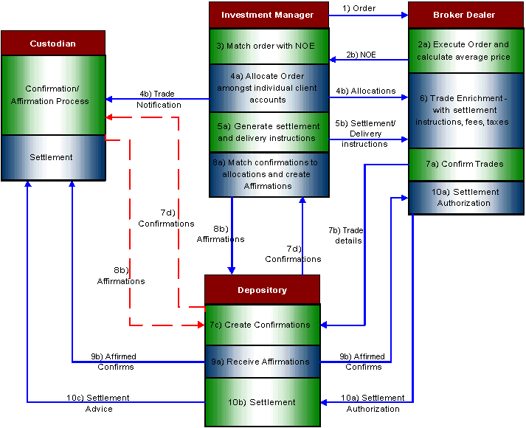
Sl. No | Description
1 | On Trade date T, the investment manager places an order to the broker dealer which in turn places the order on the exchange
2a. | Once the counter party has been identified and the order has been executed, the broker calculates the average price
2b | The broker dealer sends the Notice of Execution(NOE) to the investment manager to report the execution of the order
3 | Once the investment manager receives the NOE, he matches it with the order to find out the discrepancies
4a | Once the order matching with the NOE is done and there are no discrepancies, the investment manager allocates shares among the client accounts
4b | The investment manager sends the allocation messages to the broker dealer and the trade notification message to the Custodian
5a | Once the allocations are sent to the broker, the investment manager generates settlement and delivery instructions
5b | The Investment Manager sends the settlement and delivery instructions to the Broker dealer
Between T+1 and T+2 the Broker dealer enriches the trade details with settlement instructions, fees, commissions and tax details
7a | The Broker dealer confirms the trade details
7b | Based on Allocation message from the investment manager, brokers submit trade details to Depository
7c | Depository then creates trade confirmations
7d | Depository forwards the trade confirmations to the investment manager with copies to the broker and custodian bank
8a | The investment manager matches the allocations with DTC sent Confirmations
8b | For matched Confirmations, the investment manager affirms the trade and sends an affirmation back to DTC
Between Noon of T+2 and T+3
9a | The Depository receives the affirmations from either the investment manager or custodian
9b | The Depository sends the affirmed confirms to the Broker dealer and Custodian respectively. The depository also sends details of un-affirmed trades to the broker, who then has to resolve the same with the institutional investment manager.
10a | The Broker dealer sends settlement authorization to the depository
10b | Depository does the settlement after receiving settlement authorization from the broker dealer. Settlement is effected by depository on T+3. Shares are transferred by book-entry from the depository account of the delivering participant to that of the receiving participant, with the corresponding payment being credited to the delivering participant and debited to the receiving participant.
10c | Depository sends settlement reports to the brokers and custodian banks identifying the trades that settled on T+3 and if a delivery did not settle, specifying the reasons

Organization View
A typical IM organization are divided into three offices namely, front office, mid office and back office. The front office performs the critical investment decision making & support functions and pre-trade compliance, the mid office caters to function of trade order management, reporting functions and the back-office performs accounting and securities servicing functions. A brief description for each of the functions in front, middle and back –office of an investment manager are defined in the following section of the document.

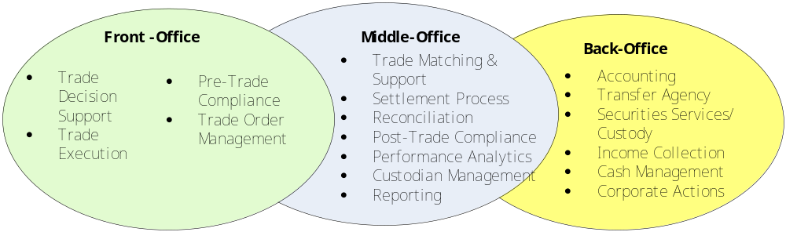

Front Office Functions
Front office of an investment manager organization performs the critical function of investment decision making. The reason why investors entrust their money with professional Investment Manager is for their superior information access and the capability/expertise to interpret that information in a meaningful way. The broad functions involved in the front office of an Investment manager are as follows:
- Trade decision support
Investment management firms have a host of research analysts who analyze the universe of equities, fixed income and derivatives instruments and prepare reports and recommendations on them. These reports are used by the portfolio managers to base their decisions on trades
- Trade order management
Once the portfolio manager decides on a trade, the trade is passed on to an order management system. This order management system routes the trade to the market place where the trade will be executed. The different stages of the trade from order entry to final confirmation of execution is managed by the order management system.
- Trade execution
The order management system is linked to the systems at the marketplace for routing the orders. The trade is then executed at the respective marketplace and the details of execution are passed on to the order management system. The portfolio manager views the details of the trade through the order management system.
For instruments that are trade Over-the-counter, the broker/dealers of the portfolio manager interacts directly with the counter party and finalizes the deal. These trades can be manually fed in the order management system or automatically.

Mid Office Functions
The mid office of an Investment manager focuses on a majority of the post-trade activities starting from Trade matching, trade support, post-trade compliance and interfacing with custodians for the trade settlement till the information is passed in for the accounting applications.
Trade matching
Once a trade is executed and the details of the trade are passed on to the custodian for trade matching. The investment management firm confirms/rejects the trade on the trade matching report prepared by the custodian
Reconciliation
During the trade matching process, the custodian prepares the trade match report and sends it to the investment manager and the broker. The investment manager reviews the report and passes back its confirmation/rejection. This reconciliation process is done by the investment management firm comparing the trades sent by them for execution with the report.
Settlement process
Once all the trades are matched and reconciled, the trades are then settled with shares and money exchanging hands.
Post-trade compliance
Once the trade is completed, the investment management firm sends a report on the executions to the regulator. This is done to ensure that the investment management firm is acting within its responsibility without flouting the rules and regulations. The compliance team in the firm prepares the reports at the end of each day and reports it to the regulators.
Investment accounting
Investment accounting forms an integral component of financial accounting. The assets entrusted to the asset management company are accounted for in accordance with the prevailing statutory bookkeeping regulations.
Performance analytics
Assets under the management of the investment manager are tracked and data is released periodically on the performance of the funds. The investment manager’s performance is calculated based on the performance of the fund vis-à-vis the benchmark (e.g. S&P500 index in US).
Client reporting
Investment management companies provide regular performance reports to the clients to inform them of the NAV, Dividends, corporate actions and other relevant details.

Back-Office Functions
Fund administration
Fund administration includes the following activities:
- Multi-currency fund accounting
- Maintain principal books and records
- Calculate Net Asset Value
- Investor services
- Process and confirm investor subscriptions and redemptions
- Distribute valuation statements and performance reports
- Corporate services
- Act as registered office and corporate secretary
- Organize meetings of shareholders and directors
- Assist in tax reporting for partnerships and taxable investors
Transfer agency
Transfer agency for fund companies perform the record keeping of shareholders of the fund. The transfer agent takes care of the shareholder communication, dividend disbursements, and proxies for the fund company
Corporate actions
The funds are adjusted according to the announcements like dividends, stock splits etc made by the corporations whose shares are held by the funds.
Cash Management
Cash Management functions include managing the movement of funds, daily cash positioning, and management of bank balances.
Securities lending
Security loans provided to other parties who may sell them short or deliver them to another party to satisfy some other obligation. Securities may be loaned for a fixed period of time, or the loans may be open-ended
Collateral Management
Collateral Management’s responsibilities include establishing account information, evaluating security issues for market value and deposit eligibility, reconciling and confirming inventory information, processing account mergers and record changes, taking legal and administrative action, and processing cash deposits, interest allocations and disbursements. Collateral Management ensures minimum collateral values are maintained and notifies participating agencies in cases of collateral deficiencies.

Industry Processes
The trade matching and messaging process is prime focus of this document. The upcoming section will elaborate on the industry process of trade matching & messaging and the role of a service provider if this process is outsourced.

Trade matching and messaging process
Post Trade matching process consists of matching the trade and generating Confirmation / Affirmation messages
A first step in settling a securities trade is to ensure that the buyer and the seller agree on the details of the transaction, a process referred to as trade confirmation and affirmation or trade comparison and matching. A dealer who executes trades on behalf of others is required to confirm trade details, not only with the counterparty to the trade (if the trade is not automatically matched at the marketplace), but also with the client for whom it acted. Agreement of trade details (sometimes referred to as trade data elements) must occur as soon as possible so that errors and discrepancies in the trades can be discovered early in the clearing and settlement process.
The typical institutional trade involves at least three parties: an investment manager or portfolio adviser (institutional client), usually acting on behalf of one or more underlying client accounts, who decides what securities to buy or sell and how the assets should be allocated among the client accounts; a dealer to execute the resulting trades; and one or more financial institutions appointed as custodian to hold the institutional client’s assets. After placing an order with, and receiving a notice of execution of a trade from, a dealer, the institutional client must provide the dealer and custodian(s) with certain details to facilitate the settlement of the trade. In particular, the institutional client must provide details with respect to the underlying client accounts managed by it, and must instruct the custodian(s) to release funds and/or securities to the clearing agency. The dealer must also issue a customer trade confirmation to the institutional client containing required information pertaining to the trade.
Settlement is to be distinguished from clearance. Clearing is the process which begins immediately after the execution of a trade, and includes the process of comparing trade data elements. It also includes the calculation of the mutual obligations of market participants, usually on a net basis, for the exchange of securities and money—a process which occurs within the operations of a clearing agency. The concept of clearing or clearance is given a broad meaning to include the process of transmitting, reconciling and confirming payment orders or security transfer instructions prior to settlement. Settlement is, on the other hand, the moment when the property right or entitlement to the securities is transferred finally and irrevocably from one investor to another, usually in exchange for a corresponding transfer of money.
Matching
The components of customer-side settlement of an institutional trade through a "matching" system are illustrated as below.
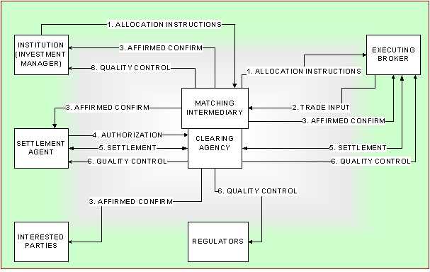
"Matching" is the term that is used to describe the process whereby an intermediary compares the broker-dealer's trade data submission (step 2) with the institution's allocation instructions (step 1) to determine whether the two descriptions of the trade agree. If the trade data and institution’s allocation instructions match, an affirmed confirmation is produced and forwarded to the institution, the broker-dealer, the institution's settlement agent, and other interested parties (e.g., trustees, plan administrators, or correspondent banks (step 3). This would eliminate the separate steps of producing a confirmation (step 4) for the institution to review and affirm (step 5). At this point, the trade goes into Clearing Agency’s settlement process but must be authorized by the delivering party agent before settlement occurs (steps 4 and 5). Quality Control" involves Clearing agency monitoring and production of various reports for regulators, brokers, and Investment managers (Step 6).
Matching is inextricably intertwined with the clearance and settlement process. A vendor that provides a matching service will actively compare trade and allocation information and will issue the affirmed confirmation that will be used in settling the transaction. In addition, matching addresses two areas: reducing errors and reducing the amount of settlement time.
The settlement process can either combine the security and the cash leg in a single legal action or treat them separately. If both legs are linked, transfer of ownership cannot be legally effective without the cash payment and vice versa. The technical term for this procedure is “Delivery Versus Payment (DVP)”. Where delivery of securities and cash payment are not linked legally, the technical term “free of payment (FOP)” is used.
As noted above, matching combines certain steps in the confirmation and affirmation process and therefore can help to reduce errors. Effective matching also will be critical in any effort to shorten the settlement cycle. At the same time, matching concentrates processing risk in the entity that performs matching instead of dispersing that risk more broadly to broker-dealers and their institutional customers. In particular, matching eliminates a separate affirmation step that would allow the detection of errors that could delay settlement or cause the trade to fail.
Confirmation / Affirmation
The confirmation/affirmation (or messaging) process refers to the transmission of messages among broker-dealers, institutional investors, and custodian banks regarding the terms of a trade executed for the institutional investor. Because the trades of institutional investors involve larger sums of money, larger volume of securities, more parties, and more steps between order entry and final settlement, institutional trades are usually more complex than retail transactions.

Role of a service provider (or Securities Services firm) in outsourcing trade matching and messaging process
Out of the complete Trade Cycle that is depicted below, the Post Trade services consisting of Trade Matching, Trade Confirmation / affirmation and Comparison can be exclusively outsourced. These are the typical functions of a service provider.
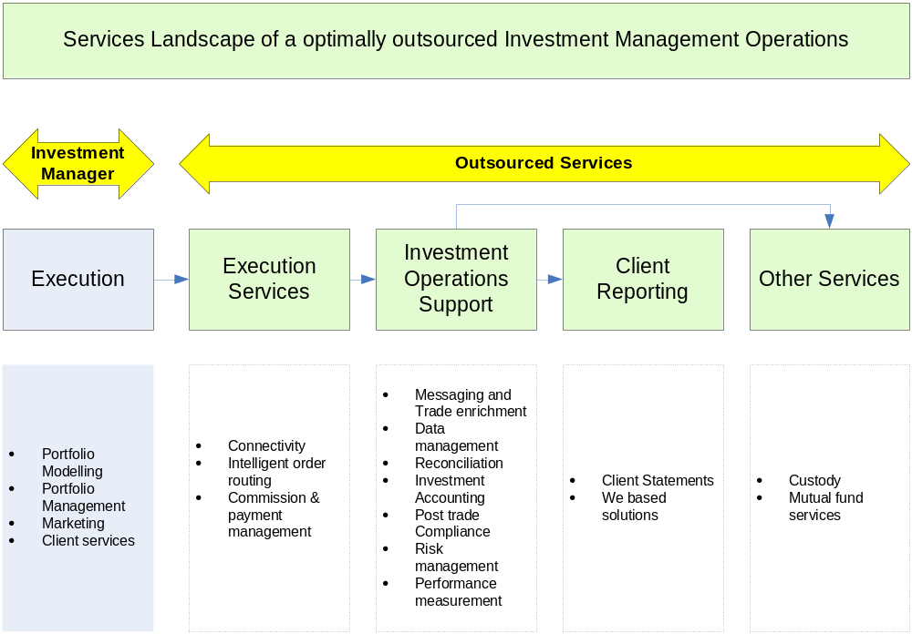

A typical securities services firm deploys an integrated Trade communication platform for trade processing services which includes trade matching, messaging and comprehensive reporting on the trades executed by the Investment managers.
The trade details from the investment managers are communicated to the securities services firms which received via the trade communication platform, the Trade communication platform interfaces with local reference data application residing in the custodian side for trade enrichment. The enriched IM trade is matched with the trade details received from the broker via Industry utilities like Oasys Global or via manual input. This platform is used for trade matching and messaging the trade details to other information delivery platforms like SWIFT (for 3rd party custodians) and to the home-grown accounting platforms.
For the service provider with a proven track record in the delivery of back-office functions, moving into middle-office territory is a natural progression. Asset servicing has become a 'specialist' function, and the processing and reporting undertaken in the middle-office are core activities for the service provider firm, just as an asset manager's core is to create returns on their fund portfolio. The move into the middle-office is therefore a logical evolution of a service provider firms existing services and it is not a revolution or radical change in direction. In addition, like custody and fund administration, the middle-office function trade matching and messaging is replicable and scalable.
Outsourcing is not only about improving efficiency and reducing cost. Through outsourcing, investment managers will also be able to achieve other important benefits such as quicker speed to market, improved breadth and delivery of client valuations and performance reporting, and reduced risk. In addition, the onus is on the service provider firms firm to maintain systems in line with the constantly shifting market requirements, as well as the changing demands of regulation.
A growing number of buy-side firms have accepted that trade matching is not a core part of their business, and they are actively seeking ways to outsource the function, while still retaining ownership. From an investment administration perspective, it is rare for an asset manager to have a single-source relationship, so effective data aggregation, manipulation and delivery becomes vitally important, as well as being labor-intensive.

Business Models
The business model provides an overview of services and outsourcing model offered in trade matching and messaging space and the revenue model adopted for each of outsourcing model.

Service Models
In matching and messaging space, service can be provided as different components as defined below;
- Formatting and Messaging Component: Client trade files are received as messages and files are formatted to either proprietary message formats or SWIFT format and delivered to the appropriate external parties.
- SWIFT Messaging Component: In this model trade files received from client will be distributed to the stake holders using SWIFT gateway
- Messaging only Component: Here the trade is already matched and responsibility of service provider is to send settlement notification to custodian and other stakeholders
- Matching and messaging component: Entire gamut of matching and messaging service which will involve receipt of trade, matching the trade, generating exception messages in case of exception, generating matching confirmation messages, receiving settlement confirmation.

Outsourcing Model
The following are some of the types of outsourcing models that can be followed by a service provider for providing matching and messaging service
- Application service provider: In this model, the technology infrastructure, application maintenance and development are transferred to the service provider. The matching and messaging service is provided by the service provider in the following revenue models:
  - Fixed cost: The outsourcing firm contracts to provide matching and messaging service for a fixed fee and the contract will have a time period of validity.
  - Time and materials: The outsourcing firm contracts to provide matching and messaging service on a variable cost which is calculated on a time and materials involved in the execution which will have volume of trade and kind of service rendered as basis;
  - Hybrid models: Combinations of variable and fixed cost services are also offered
- Lift out: In this model, service provider takes ownership of existing systems, processes and personnel involved in the operations. The revenue model that can be followed in the lift out model will be as follows;
  - Transaction basis: The outsourcing providers charge a fee on the number of transactions that are executed by the investment managers.
Different rates of transaction fee can be applied based on the kind of service that is being provided to the client. Transaction Fee incurred is dependent on the following factors:
    - The number of transactions during the period of engagement with the client
    - Full Service, Message Only or General Use Messaging client / transaction
  - Fixed cost: The outsourcing provider charges a fixed fee for a time period
  - Hybrid Model: This will be a combination of transaction basis and fixed cost basis where a fixed amount can be charged if transaction does not exceed a particular limit and if transaction exceed particular limit, transaction done over the limit can be charged on variable basis.
- BOT Model: This model will be suitable if the setup is done for first time where infrastructure will be built by service provider and the operations will be transferred to client after operations reach a steady state. The revenue model for the BOT will be as follows;
  - Management Fees: This fees will be charged for providing the following services
    - Assistance in setting up new infrastructure
    - Recruitment and staff the organization structure
    - Establishing the delivery structure
  - Operation fees: This will be charged to handle operations of the new setup
  - Transfer fees: This fee will be charged to handle the transfer operation after the operations reach the steady state. Transfer fee may comprise the following parts;
    - Asset transfer fee
    - Talent transfer fee

Process Overview

Process Diagram
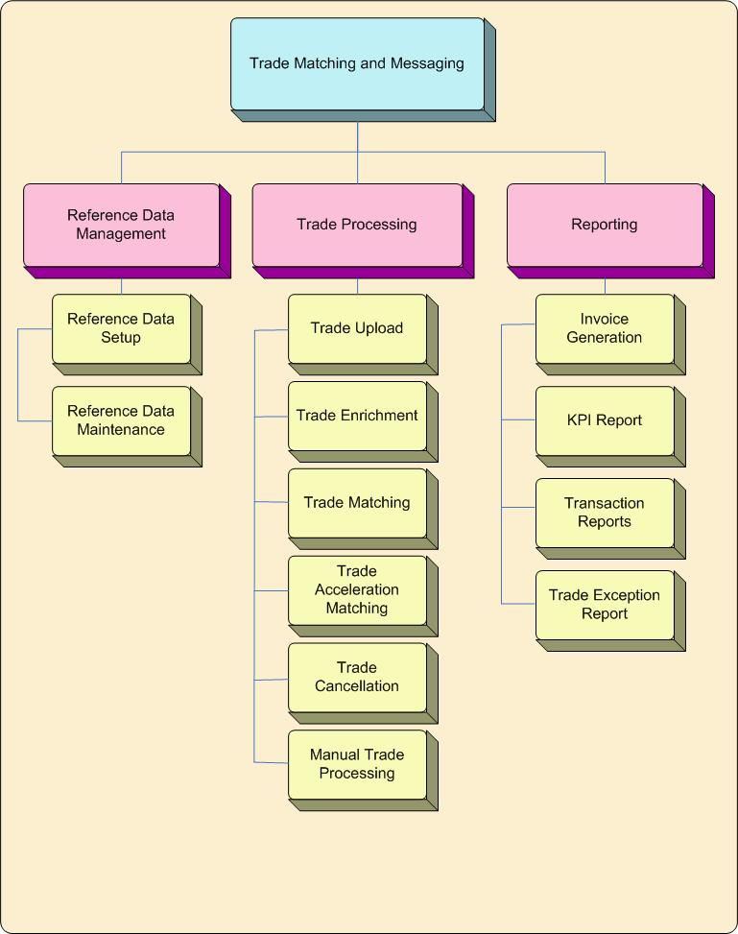

Key Processes

Reference Data Management

Reference data is the fundamental data defining the securities, customer, Counterparty, workflow rules etc. Reference data is pre-requisite for processing any transactions in the trade matching system. Reference data for trade matching system can be broadly classified as common reference data and specific reference data where, common reference data is general reference data required for trade matching system irrespective of the client, I.e., it will not change for each client whereas specific reference data will vary from client to client. Various types of reference data required for trade matching system is listed below;
- Common Reference Data
- Security Data
- Counterparty Data
- Currency Detail
- Market Detail
- Specific Reference Data
- Client Data
- Routing rules
- Matching Rules
- Settlement Details
- Trade Enrichment Data
Reference data management involves the following activities;
  - Setup Reference Data
  - Maintain Reference Data

Reference Data Setup and Maintenance
Reference Data Setup: Reference data setup is the process of creating the pre-requisite data required for effective functioning of the trade matching system. This will be done initially when trade matching process is taken over from an investment manager and when ever a new data is to be added on account of the following;
- A new instrument being traded by investment manager
- Trading is to be performed in a new currency
- A new counterparty is identified by the investment manager
- Changes required in routing policies
- New place of settlement
Reference Data Maintenance: Reference data maintenance process involves changing the reference data already available for the following reasons;
- IM decision to change routing rules, messaging address
- Change in the currency name
- Change in matching requirements
- IM decision to opt for more service (From messaging only to matching and messaging)
- Change in custodian deadline details
Please refer Cognizant reference data framework for managing the reference data

Trade Processing

Trade Upload to Trade matching system
Trade details are uploaded by both Investment Manager and counterparty. In case of investment manager, trades for which Notice of Execution (NOE) is issued will be uploaded for further trade matching. In the case of counterparty, all trades which are executed will be forwarded for trade matching. This process involves uploading the details to trade matching system and receipt of confirmation / exception details from the trade matching system. There are various ways in which trade details will be uploaded by the entities and some of them are as follows;
- Direct entry in the trade matching system
- Trade details uploaded through a file using a proprietary interface
- Trade details upload by Oasis Global Workstation
- Trade upload by sending a SWIFT Message
In case of automatic trade upload, data is uploaded thru a file. The file which is uploaded will be conforming to pre-defined file format. Uploaded trade details will undergo basic validation check during upload process. In case of any exception in the upload process, exception messages will be generated to the corresponding stake holders (Investment Manager or Broker).
The following are the activities performed in the trade upload process;
- Upload of file into trade matching system
- Trade is converted in the pre-defined standard format as required by trade matching system
- Data is validated for exceptions
- In case of exception, file is rejected and exception message is forwarded to the Investment manager and counterparty
- In case no exception is generated, file is processed further

Trade Enrichment
Trade enrichment is process of populating the other trade details which is not communicated by the IM. I.e., if some the enrichment details are already provided by IM then only whatever is required will be enriched, otherwise all enrichment details will be obtained based on the rules pre-defined. The following are some of the types of enrichment details;
- Exchange fees
- Broker Commission
- Accrued Interest (Interest bought or interest sold)
- Market Charges
- Taxes /levy
- Settlement Details (From Standing settlement instructions)
- Internal Account Numbers
A trade will be matched prior to enrichment or after enrichment based on routing rules defined for the kind of trade. Trade enrichment will done either by trade enrichment module in the trade matching system or by any other external trade enrichment system. Decision to enrich internally or externally will be based on the routing rules defined.
The following are the activities performed in the trade enrichment process;
- Checking incoming data for trade enrichment exceptions. For example non-availability of enrichment details, wrong master details etc.
- Calculation of broker commission, accrued interest, market charges, exchange fees
- Enrichment of data with the additional details
- Enriched data forwarded for trade matching
- In case of enrichment exception, trade will be routed for further investigation

Trade Matching
Trade matching is a process of matching the IM side trade with that of counterparty side trade confirmation and generating notifications / exceptions to the stake holders (Namely, Investment Manager, counterparty, Custodian and Account Holder). The matching will be either an exact match or tolerance match or force match. Trade matching will be done for two types of trade data, namely allocation trade and block trade. Matching allocation trade involves matching one trade of the investment manager with one confirmation from broker. In case of block trade, single trade instruction from the investment manager would have been executed in various blocks by the broker hence for a single trade from the investment manager more than one trade confirmation would be received from the broker.
The trade matching logic is one of the key element of the trade matching. Trade matching logic will be different for different type of instruments (Namely, securities, fixed income instruments, foreign exchange, derivatives and money market instruments), clients and markets. Trade matching logic will involve matching of parameters of the both side trade and the parameters are classified into key parameters and additional parameters. In the case of exact match, all key parameters and additional parameters has to match. In the case of tolerance match, if key parameters match but additional parameters match within a tolerance limit then it is termed as tolerance match. Please note that matching of key parameters exactly is a pre-requisite for tolerance match.
Securities
The matching parameters for Securities, fixed income instruments, derivatives comprise;
Key Parameters | Additional Parameters
Securities Identifier | Equities
Transaction Type | Price
 | Settlement Date
Client | Gross Consideration
Trade Date | Broker commission
Trade Currency | Overseas charges
Settlement Currency | Contract Total
 | Fixed Interest Instruments / Unit Trust Transactions
 | Gross consideration
 | Accrued Interest Value
FOREX
Key matching parameters for foreign exchange comprise;
Key Parameters | Additional Parameters
Client | Buy Amount
Counterparty | Sell Amount
Account | Exchange Rate
Buy Currency
Sell Currency
Trade Date
Value Date

Money Market Instruments
Key matching parameters for Money Market Instruments namely, Fixed and call deposits, Loans, Commercial Paper, Certificate of Deposit
Key Parameters | Additional Parameters
Client | Maturity Date
Counterparty | Interest Amount
Currency | Interest Rate
Principal Amount | Day Count
Trade Date
Value Date
Account
The following are the activities performed in the trade matching process;
- Trades will be received for matching after enrichment if it is applicable.
- Key parameters of the enriched / not-enriched trades will be matched, which is called first level matching
- On successful completion of first level matching, additional parameters will be matched if applicable
- On successful matching notification will be sent to counterparty, Investment Manager, Custodian and Account holder. Notification may be a SWIFT message or Fax Notification or Email notification.
- If there is any mismatch in the first level matching or second level matching, exception message will be generated to the stake holders based on the routing rules and the trade is routed for further investigation
Interfacing with external trade matching system
In case client has subscribed for messaging only service component, matching happens in an external system and messaging will be done by the trade matching system. In such cases, IM trade details will be forwarded to the external trade matching system for matching. If the trades match, broker trade confirmation is received from the external trade matching based on which message is generated to the stakeholders.

Trade Acceleration Matching
Accelerated trade matching happens when broker confirmation is received subsequent to trade acceleration and trade is matched with IM trade.
The following are the activities performed in trade acceleration matching;
- Matching confirmation messages to stakeholders will be suppressed as confirmation message would have been already generated during trade acceleration.
- In case of exception during the matching, exception message will generated canceling the previous matching message and trade will be routed for further investigation

Trade Cancellation
Trade Cancellation is a process of terminating the trade by generating cancellation instruction. Trade cancellation will be necessitated under following circumstances;
- Cancellation of unmatched trade by IM
- Cancellation of unmatched trade by counterparty
- Amendment of a matched trade
- Amendment of an unmatched trade
- Incorrectly force matched trade
- Cancellation of trade by IM prior to settlement
- Cancellation of trade by broker prior to settlement
The following are activities performed in trade cancellation process;
- Generally cancellation instruction will be same as trade instruction but will be tagged with the status “Cancelled”.
- Based on the status in which the trade is at time of cancellation, activities performed during cancellation will vary
Timing of cancellation | Action taken
Cancellation of Trade prior to trade matching (Either side A cancellation or side B cancellation) | - Trade will be tagged as cancelled and will be moved to cancelled trade area
Cancellation of trade by IM after matching Prior to settlement | - The trade match will be removed  - Transaction will be tagged as cancelled and moved to cancelled trade area  - Message to cancel the confirmation message (generated during trade matching) will be send to stake holders  - Side B trade will be tagged as unmatched and will become eligible for trade matching
Cancellation of trade by counterparty after matching but prior to settlement | - The trade match will be removed  - Transaction will be tagged as cancelled and moved to cancelled trade area  - Message to cancel the confirmation message (generated during trade matching) will be send to stake holders  - Side A trade will be tagged as unmatched and will become eligible for trade matching

Manual Trade Processing
Even though trade matching and messaging system is supposed to automate the trade matching process, there will be time where some of the exceptional conditions will need manual intervention. Some of such exceptional conditions are discussed below;

Manual Trade Entry
In case automatic upload fails or some problem prevents happening of automatic upload, trade details will be manually entered by the operations team of IM / counterparty using an interface available in the trade matching system. Details entered manually will be checked for exceptions as done for automatic upload and if there is no exception, manually entered trades will handled similar to automatically uploaded trade

Trade Acceleration
Trade Acceleration is the process of forwarding IM’s trade instruction for further processing even if the broker confirmation is not received. I.e., it is construed as trade is matched and trade matching notification is forwarded to the stake holders. In case counterparty confirmation is received subsequent to trade acceleration, then the corresponding trades will under go a process called trade acceleration matching. Please note that only IM trade instruction can be accelerated and not counterparty trade confirmation. An accelerated trade will be kept in unmatched status till counterparty confirmation is received

Force Trade Matching
In force matching, irrespective of non-matching of some of key parameters or exceeding tolerance limit in additional parameters, trades will be matched by user. Please note that even though trade is force matched, it is mandatory that some of the key parameters should match

Investigate
Investigate is a process of segregating trades with exception for further investigation and rectification of exception. Trades will be routed for further investigation in the following circumstances;
- Investment manager / counterparty error is identified subsequent initial validation
- Match has not been received from IM / counterparty within user defined period
- Custodian deadline is reached
- Exception during acceleration matching
- Trade Enrichment Exceptions
- Exceptions during trade cancellation
- Duplication of trade details
During the investigation process the underlining problem is identified and corrective action is taken

Trade Withholding
The process of withholding a trade from getting processed further if there is a specific need to hold the trade is called trade withholding. In this process, trade will be withheld permanently till it is released for further processing. A withheld trade can also be cancelled.

Settlement Notification
Once a trade has been matched successfully, based on the Standing Settlement Instruction, settlement path and settlement message format for the transaction will be determined. Based on the settlement message format, settlement notification messages will be generated to custodians.

Trade Settlement Monitoring
On settlement of trade by custodians, custodians will send a settlement confirmation to trade matching system which is tagged against the trade. This information is used for the purpose of reporting it to stake holders. In case of cancellation and re-booking of trades, original settlement confirmation will be cancelled and the latest status will be updated. The following are the type of settlement confirmation received from custodian;
- Confirmation of settlement
- Cancellation of settlement
- Reversal of confirmation

Generation of record keeping messages to custodian
Record keeping messages are generated to the custodian on need basis. As the name signifies, these messages are sent just for record keeping purpose. The record keeping messages can be classified as Soft record keeping messages and hard record keeping messages.
Soft Record Keeping Message: A message is sent to custodian on receipt of IM trade details. In case of proper match, no confirmation message is generated. In case of tolerance match, a confirmation message is sent again and the old record keeping message is cancelled.
Hard Record Keeping Message: A record keeping message is sent to custodian only if trades match.

Reporting
Reporting is the process of generating either periodic / adhoc reports. The reports can be classified as follows;
- Invoice
- Dashboard Reports
- Summary Reports
- Detail Reports

Process Model

Eco System
The ecosystem provides an overview of who is interacting with the system and what information is shared between the system and the entity/participant. It represents all the entities/participants that interact with the trade matching system. It means that these participants either provide an input or retrieve some output from the system. The participants may be an individual or another system. These entities/participants may be external to the system; for example custodian system is external to trade matching system. But the trade matching system provides settlement instructions to the custodian system as input. Moreover, custodian system provides the information about trade settlement (if applicable) to trade communication system

Eco System Model
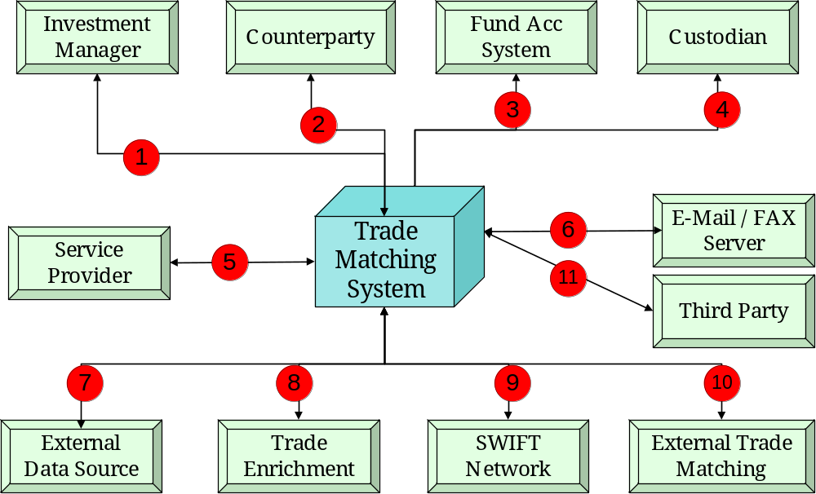

Eco System - Entities Interaction Details
Sl. No. | Participant Name | Description
 | Investment Manager | The trade details of investment manager (called side A details) is one of the core data required for the system for trade matching. The following are some of the interface thru which an investment manager trade details are updated in the system.  - Direct entry of details  - Order Management Systems  - SWIFT  - Any proprietary system used by IM
 | Broker | The broker confirmation is other core detail (called side B details) required for trade matching. The following are some of the interface thru which a broker confirmation is updated in system.  - Direct entry of details  - Oasys Global Workstation  - DTCC Interface  - Any proprietary system used by broker
 | Fund Accounting System (AS) | Confirmation of trade matching details needs to be sent to investment accounting system for record keeping and other “Back Office” operations. The following are some of the interfaces thru which matching confirmation is sent to FAS;  - SWIFT Messages thru SWIFT network  - SWIFT Messages to proprietary systems  - Proprietary message formats  - Email, Fax
 | Custodian | Confirmation of trade matching details needs to be sent to Custodian for record keeping and settlement operations. The following are some of the interfaces thru which matching confirmation is sent to CMS;  - SWIFT Messages thru SWIFT network  - SWIFT Messages to proprietary systems  - Email, Fax
 | Service Provider | Service provider will use trade matching system to handle trade processing activities such as force trade matching, trade acceleration, manual trade entry, tracking the trade, handling exceptions and reporting
 | FAX Server / E-mail Server | Fax server will be used in cases where notification is required thru fax  E-mail server will be used in cases where notification is required thru E-mail
 | External Data Sources | Trade matching system needs to interact with other external data sources for support matching and external communication. Some of the additional data required for facilitating trade matching are as follows;  - Standing Broker Settlement Instruction  - Account Booking Instructions  - Cross referencing of account, security and broker details  - Security Master Information
 | Trade Enrichment System | Trade enrichment will be performed on an external application in cases where enrichment details are not provided by investment manager.
 | SWIFT Network | This is the single interface gateway for exchanging SWIFT messages (Sending and receiving SWIFT messages)
 | External Trade Matching System (ETM) | Interfacing with other trade matching system where clients have opted for message only service and trade matching will be done by external trade matching system(s). Based on the trade match received from external trade matching system, message will be generated from the local trade matching system
 | Third Party | Clients of the investment manager who may require data feed from trade matching system

Use Case View
A use case can be thought of as a collection of possible scenarios related to a particular goal. I.e., the way users will use a system
Notations Used
Notations | Description of Notation
 | An actor is a person or another system outside of a system that interacts directly with it as part of a coherent work unit (a use case). An Actor element characterizes the role played by an outside object; one physical object may play several roles and therefore be modeled by several actors
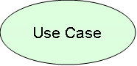 | A use case is a coherent unit of functionality provided by a system as manifested by sequences of messages exchanged among the system and one or more outside actors together with actions performed by the system
 | The communication relationship between an actor and use case

Use Case – Macro Level
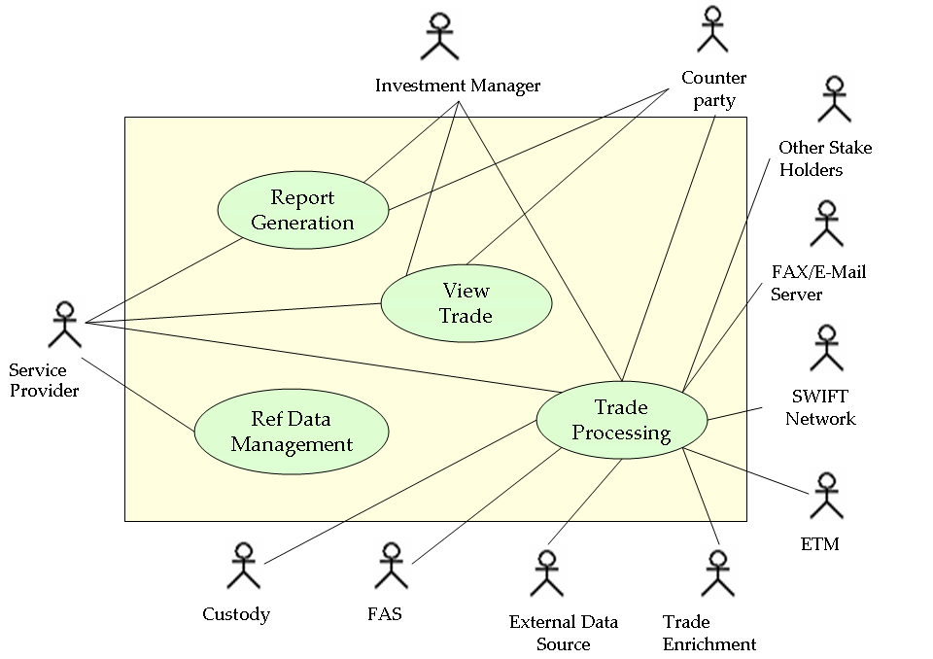

Use Case – Detail Level

Ref Data Management
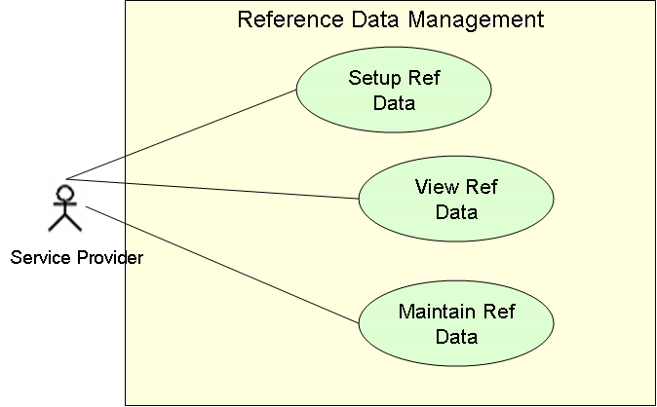

Trade Processing
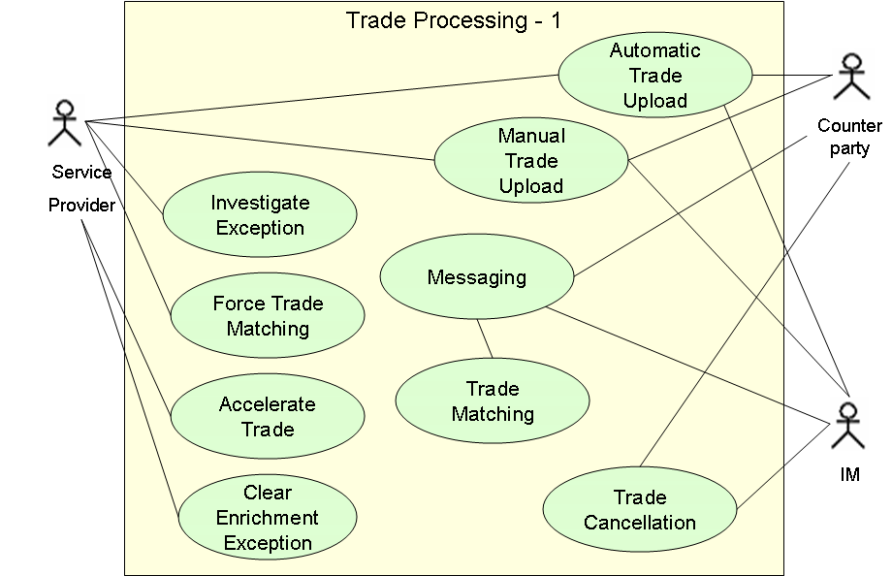

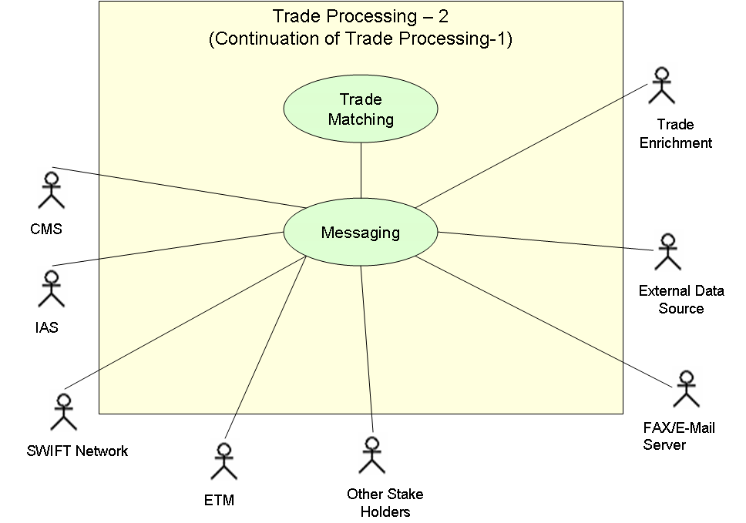

Report Generation
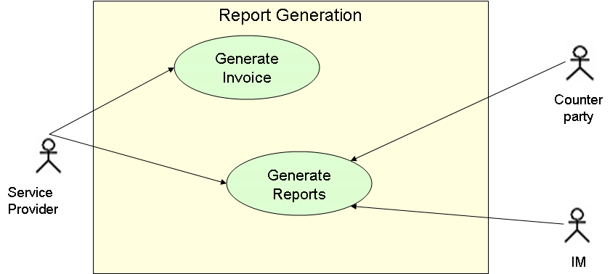

Use Case Description

Reference Data Setup
Use Case ID: | UC_001
Summary | This use case deal with creation of reference data pertaining to new users, new securities and other miscellaneous data, by the users of the service provider operations team.
Priority | High
Primary Actor | Operations team of the service provider
Secondary Actor(s)
Pre-conditions | - A new instrument is being traded by the investment manager  - A new counterparty identified by investment manager  - A new account added by investment manager  - Trading done in a new currency  - A change requested by IM in message routing (for e.g. Trade enrichment process moved from external system to internal system)
Trigger | User invoked
Basic Flow | Need for adding a new reference data will arise in the following situations;  - IM deciding to trade in a new instrument  - IM deciding to trade with a new broker  - Selecting a new location to invest which will transpire into trading in new currency  - A new account added by investment manager  - Changes made in message routing policy. For example an account holders request for receipt of confirmation message which he has not requested previously.  - When new settlement instructions are received  When ever there is a need for adding new reference data, the requirement will be communicated by the operations team of IM to the operations team of service provider.  The operations team of the service provider will access the trade matching and messaging system and add the necessary data using the reference data management module
Post-conditions | A new Reference Data is created.
Alternate Flow(s)
Frequency | As needed
Exceptions
Special Requirements | All changes of values will be recorded. Historical data must be retained and auditable, Introduction of new data should not impact the existing trade data.
Dependent Use Case
Includes
Description
Non-functional requirement
Performance Requirements:
Reliability | Should be available round the clock
Security Requirements: | Permission to add, reference data will be restricted to specific users and may require secondary authorizations.

Reference Data Maintenance
Use Case ID: | UC_002
Summary | This use case deals with managing the reference data which will involve updating the existing data or removing unwanted data, by the users of service provider operations team
Priority | High
Primary Actor | Operations team of the service provider
Secondary Actor(s)
Pre-conditions
Trigger | User invoked
Basic Flow | Need for modifying a reference data will arise in the following situations;  - IM decision to change routing rules, messaging address  - Change in the currency name  - Change in matching requirements  - IM decision to opt for more service (From messaging only to matching and messaging)  - Change in custodian deadline details  When ever there is a need for changing an existing reference data, the requirement will be communicated by the operations team of IM to the operations team of service provider.  The operations team of the service provider will make the necessary changes in the system using the reference data management module of the trade matching and messaging system and will provide confirmation to operations team of IM
Post-conditions | An updated Reference Data is created containing the new information.
Alternate Flow(s)
Frequency | As needed
Exceptions
Special Requirements | All changes of values will be recorded. Historical data must be retained and auditable
Dependent Use Case
Includes
Description
Non-functional requirement
Performance Requirements:
Reliability | Should be available round the clock
Security Requirements: | Add, Modify and delete will be restricted to users with permission only and may require secondary authorizations  View (read-only) rights may be restricted to separate list of users with permission only

View Reference Data
Use Case ID: | UC_003
Summary | This use case deals viewing the reference data by the users of service provider operations team
Priority | High
Primary Actor | Operations team of the service provider
Secondary Actor(s)
Pre-conditions
Trigger | User invoked
Basic Flow | Reference data will be viewed by the operations team of the service provider to check the current reference data values. For viewing the reference data, appropriate input will be accepted from user and based on the input, system will display the required reference data.
Post-conditions
Alternate Flow(s)
Frequency | As needed
Exceptions
Special Requirements
Dependent Use Case
Includes
Description
Non-functional requirement
Performance Requirements:
Reliability | Should be available for 24 hours
Security Requirements: | Modify and delete will be restricted to users with permission only.  View (read-only) rights may be restricted to separate list of users with permission only

View Trade Details
Use Case ID: | UC_004
Summary | This use case deals with viewing trade details by the users from service provider operations team, Investment Manager operations team and counterparty operations team
Priority | High
Primary Actor | Operations team of service provider
Secondary Actor(s) | Operations team of investment manager  Operations team of the counterparty
Pre-conditions
Trigger | User invoked
Basic Flow | Operations team of service provider will view the trading details to handle trade mismatches, trade exceptions and for general follow-up  Operations team of IM will view trading details to identify trade mismatches and trade exception to follow up with service provider  Operations team of broker will view trading confirmation details to identify mismatches and exceptions to follow-up with investment manager  The following are various details that can be viewed;  - Current Trade  - Matched Trades  - Un-matched trades  - Trade Enrichment Exception  - Duplicate Entries  - Cancelled Trades  - Search Trade  - Data upload exceptions  To view the details, appropriate input data is accepted as input from user and trade details will be displayed based on the input provided
Post-conditions
Alternate Flow(s)
Frequency | As needed
Exceptions
Special Requirements | All changes of values will be recorded. Historical data must be retained and auditable
Dependent Use Case
Includes
Description
Non-functional requirement
Performance Requirements:
Reliability | Must be available during business hours. I.e., typically during market hours
Security Requirements: | Each actors should be able to view only what is required for him. For example operations team of IM should be able to view only his trade details and mismatches/exceptions arising out of his trade

Trade Processing

Automatic Trade Details Upload
Use Case ID: | UC_005_1
Summary | This use case deals with upload of trade details automatically into trade matching system by the users of IM operations team and operations team of the counterparty
Priority | High
Primary Actor | Operations team of Investment Manager and Counterparty
Secondary Actor(s) | Custody Management System  Investment Accounting System
Pre-conditions
Trigger | User invoked or automatically scheduled based on the system used by IM/Broker
Basic Flow | Investment Manager: IM will initiate trade by placing a trade order with broker. Details of such orders are grouped and uploaded to trade matching system on a periodical basis. Generally the upload will thru a file  Counterparty: Trade request placed by investment manager will be executed and Notice Of Execution (NOE) will be provided by Broker to IM. All such trades are grouped and uploaded for trade matching on a periodical basis. Generally the upload will thru a file. The following will be the sequence activities followed in trade detail upload;  - The trade file will be received and validated  - In case of exception an exception message will be generated to IM or counterparty based on entity from whom file is received  - In case there is no exception, the file will be converted into the format acceptable to trade matching and messaging system  - Details of the file will be uploaded into the system  - A message will be generated to the stake holders
Post-conditions | If the trade is successfully uploaded into trade matching system then an acknowledgement will be received otherwise the uploaded file will be rejected with exception.  The trade will be forwarded for trade enrichment and matching  Record keeping messages will be sent to Custody Management System and Investment Accounting System. Please note that record keeping messages will be sent only if that service is explicitly requested
Alternate Flow(s) | Manual trade details entry which is discussed as separate use case
Frequency | As needed
Exceptions | - Uploaded file rejected by trade matching system due to non-conformance to standard file format  - Uploaded file rejected by trade matching system due to wrong data
Special Requirements
Dependent Use Case | Trade Messaging, Trade Matching
Includes
Description
Non-functional requirement
Performance Requirements:
Reliability | Must be available during market hours
Security Requirements: | Permission for trade upload will be provided only to specified users

Manual Trade Details Entry
Use Case ID: | UC_005_2
Summary | This use case deal with manual entry of trade details by the users of IM operations team and operations team of counterparty. Manual data entry will be done only in cases where automatic data upload fails
Priority | High
Primary Actor | Operations team of IM and operations team of broker
Secondary Actor(s)
Pre-conditions
Trigger | Failure of automatic upload process
Basic Flow | In case automatic upload fails or some problem prevents happening of automatic upload then, trade details will be manually entered and the following process is followed in manual trade entry  - The required details are accepted from user  - User enters the details and it will be validated by the system  - If the data pass thru validation, data will be uploaded into the system otherwise user will be prompted to rectify the wrongly entered data
Post-conditions | Trade details will be recorded in the trade matching system and will be forwarded to trade enrichment and subsequently to trade matching  Record keeping messages will be sent to Custody Management System and Investment Accounting System. Please note that record keeping messages will be sent only if that service is explicitly requested
Alternate Flow(s)
Frequency | As needed
Exceptions
Special Requirements
Dependent Use Case | Trade Messaging, Trade Matching
Includes
Description
Non-functional requirement
Performance Requirements:
Reliability | Must be available during market hours
Security Requirements: | Permission for manual trade entry will be provided only to specified users

Trade Matching
Use Case ID: | UC_005_3
Summary | This use case deals with matching the counterparty trade and generating messages to stake holders
Priority | High
Primary Actor | Messaging interface
Secondary Actor(s)
Pre-conditions | Both Side A and Side B trade should have been received
Trigger | Automatically triggered on receipt of matching side A and side B details.
Basic Flow | On receipt of Side A and side B trades, matching is done based on the pre-defined matching criteria. The automatic matching happens at two level namely, clear or perfect matching and tolerance matching.  If all the parameters of the counter party trade matches then it is called clear or perfect match and if trade matching happens within a tolerance limit, it is called tolerance matching  If matching of two sides happens after acceleration of side A then it is called accelerated trade matching. The following is the sequence of activities followed in matching process;  - The system keeps track of trades received  - Every trade on its receipt is compared with the trade already available.  - If the trades match, confirmation messages are generated automatically and send to stake holders based on the routing rules specified  - If trades does not match, it will be stored in separate area and if any trade is received subsequently it will be matched with the trade in unmatched trade area  Please note that, it is not mandatory that Side A and Side B details are to be received in sequence. I.e., side A should have been received prior to side B
Post-conditions | Generation of trade confirmation messages to stake holders
Alternate Flow(s)
Frequency
Exceptions
Special Requirements
Dependent Use Case | Trade messaging
Includes
Description
Non-functional requirement
Performance Requirements: | Should be able to process minimum 2000 trades an hour
Reliability | Must be available during market hours
Security Requirements: | Messages to be generated only for the applicable stakeholders and not to all

Force matching of trade
Use Case ID: | UC_005_4
Summary | This use case deals with performing force match of two unmatched trades by the users of service provider operations team
Priority | High
Primary Actor | Operations team
Secondary Actor(s)
Pre-conditions | - Key elements should match  - Secondary elements do not match or exceed matching tolerance
Trigger | - User invoked on need basis
Basic Flow | Side A and side B trades which match in key elements and exceed tolerances in secondary elements are selected and force matched. Once force matched, the trade flow logic will be same as matched trades.  The following is the sequence of activities followed in force matching a trade  - The trades to be matched are selected and matched manually by user  - The trade selection will be allowed only for trades where primary elements match and there is variance in secondary elements.  - On matching the trade, confirmation message is generated to the stake holders.
Post-conditions | The force matched trade will follow the trade flow of regular matched trade.
Alternate Flow(s)
Frequency | As needed
Exceptions
Special Requirements
Dependent Use Case | Trade Messaging, Trade Mismatch
Includes
Description
Non-functional requirement
Performance Requirements:
Reliability | Must be available during market hours
Security Requirements: | Permission to process force matching will be permitted only for selected users  Permission to View (read-only) force matched trade will be restricted to specific users only

Trade Acceleration
Use Case ID: | UC_005_5
Summary | This use case deals with the process of trade acceleration by user of service provider operations team if side B details are not forth coming
Priority | High
Primary Actor | Operations team
Secondary Actor(s)
Pre-conditions | Side B trade details are not forth coming
Trigger | User invoked, Approaching custodian deadline for a Side A trade
Basic Flow | On need basis, a side A trade will be selected by the users and accelerated, triggering confirmation messages to the stake holders
Post-conditions | Trade will be stored in un-matched folder till side B details are received and trade is matched
Alternate Flow(s)
Frequency | As needed
Exceptions
Special Requirements
Dependent Use Case | Trade Messaging
Includes
Description
Non-functional requirement
Performance Requirements: | Default system performance criteria
Reliability | Must be available during market hours
Security Requirements: | Permission to accelerate a trade will be permitted only for selected users  Permission to View (read-only) accelerated trade will be restricted to specific users only

Trade Investigate
Use Case ID: | UC_005_6
Summary | This use case allows users from the operations team of service provider to clear data mismatch by providing appropriate details
Priority | High
Primary Actor | Operations team
Secondary Actor(s)
Pre-conditions | - Any error in the side A trade details  - Any error in the side B trade details  - Side B trade received and side A trade not received within stipulated period of time  - Side A trade received and side B trade not received within stipulated period of time  - Custodian deadline approaching for unmatched trade
Trigger | Manually initiated by user
Basic Flow | A trade will be validated at two levels before being taken up for matching;  - Validation for confirmation of data structure with the standard specified  - Validation of details with the reference data  If a trade detail fails at the second level of validation , it will be flagged as mismatch and stored separately for further investigation  Trades for which counter party trade details not received within stipulated period of time will also be flagged as mismatch and stored separately for further investigation  Trades for which custodian deadline is approaching will also be flagged as mismatch and stored separately for further investigation.  The following are sequence of activities carried out to investigate and clear exception  - The investigate condition of a trade is evaluated periodically  - Any trade which becomes eligible for investigation will be flagged moved to appropriate location for investigation  - User will manually analyze the trade in investigate status  - User will rectify the exception by providing appropriate details  - The trade will be forwarded to next level of approval.  - User will approve the details and the trade will be forwarded to next level based on routing rules
Post-conditions | A trade cleared of exception will be forwarded to next level based on the routing rules
Alternate Flow(s)
Frequency | As needed
Exceptions
Special Requirements
Dependent Use Case
Includes
Description
Non-functional requirement
Performance Requirements:
Reliability | Must be available during market hours
Security Requirements: | Permission to investigate and clear data mismatch will be provided only to specific users

Trade Cancellation
Use Case ID: | UC_005_7
Summary | This use case deals with cancellation of a trade by users of Operations team of Investment Manager and Operations team of counterparty
Priority | High
Primary Actor | Operations team of the Investment Manager and Operations team of counterparty
Secondary Actor(s)
Pre-conditions | - Trade already uploaded into trade matching system  - In case of broker trade cancellation, IM should have already cancelled the trade
Trigger | - Cancellation of the trade by the account holder  - Investment Manager deciding to cancel the trade  - Amendment of trade details (Cancellation and re-booking)
Basic Flow | Trade details are uploaded into trade matching system after the trade has been initiated. A trade cancellation will be initiated based on the IM requirement or based on the request from account holder  If for some reason account holder / Investment manager decides not to go ahead with the trade or if trade amendment is required then the trade request will be cancelled and cancellation details will be uploaded into the trade matching system. If IM cancels a trade then broker will also have to initiate cancellation of trade.  The following are sequence of activities followed in trade cancellation  - The file with cancellation trade will be uploaded by the user  - The file will be validated by the system if there is any exception the file will be rejected and exception message will be generated.  - If free of exception data will be uploaded into the system  - Corresponding trade will marked as cancelled by the system and forwarded for second level of approval  - On second approval trade will be moved to separate area.
Post-conditions | IM Canceling the trade prior to Trade Matching  - Trade will be cancelled and forwarded to second level of approval  - On approval, trade will be marked as cancelled and moved to separate area  IM Canceling the trade subsequent to trade matching  - Trade will be marked as cancelled and forwarded for second level of approval  - On user providing the second level of approval, link between the side A and side B trade will be broken  - Original trade will be marked as cancelled  - Custodian will be notified to cancel the settlement instruction  Broker canceling the trade prior to trade matching  - Trade will be marked as cancelled and forwarded to second level of approval  - On approval, trade will be moved to separate area  Broker canceling the trade subsequent to trade matching  - Original trade will be marked as cancelled and forwarded to second level of approval  - On approval, trade will be moved to separate area
Alternate Flow(s)
Frequency | Need based
Exceptions
Special Requirements
Dependent Use Case | Trade Messaging
Includes
Description
Non-functional requirement
Performance Requirements:
Reliability | Must be available during market hours
Security Requirements: | Permission to upload trade cancellation details will be provided only to specific users

Trade Messaging
Use Case ID: | UC_005_8
Summary | This use case deals with generating and receiving of messages by trade matching system and taking appropriate actions based on the messages received
Priority | High
Primary Actor | Investment Manager, Counterparty
Secondary Actor(s) | CMS, IAS, E-Mail Server, FAX Server, External Trade Enrichment System, External Data Source, Central Trade Matching System, Trade Matching Engine
Pre-conditions | Transaction should have happened in the trade matching system
Trigger | Trade Matching, Trade Exceptions, Enrichment Exceptions, Requirement for external trade enrichment, Requirement of external data, trade matching by external system
Basic Flow | Trade messaging is core of the trade matching system. When ever there is message generating event, message is generated according to the messaging rules specified. The following will be list of message generating events;  - Trade upload  - Trade matching  - Exception in file upload  - Trade Cancellation  - Trade Acceleration  - Trade Acceleration matching  - Force matching  - Receipt of files / confirmation from external systems  The following is the sequence of activities performed in messaging process;  - The system will keep track for message generating events or file uploads.  - Messages will be generated or the files received will be processed based on the routing rules specified.
Post-conditions
Alternate Flow(s)
Frequency | As per requirement
Exceptions
Special Requirements
Dependent Use Case
Includes
Description
Non-functional requirement
Performance Requirements: | Should be able to process minimum 2000 trades an hour
Reliability | Must be available during market hours
Security Requirements:

Trade Enrichment Exception
Use Case ID: | UC_006
Summary | This use case deals with handling of trade enrichment exceptions by the operations team of the service provider
Priority | High
Primary Actor | Operations team of the service provider
Secondary Actor(s)
Pre-conditions
Trigger | Manually initiated by the users
Basic Flow | Side A trades with enrichment exceptions will be stored separately for investigation and further action. The following will be the sequence of activities performed in clearing trade enrichment exception;  - The trades with enrichment exception will be stored in separate area. Users will analyze the trade manually  - On identification of exception, users will rectify the data  - On rectification, trade will be forwarded for trade enrichment and subsequent to trade enrichment it will be forwarded to trade matching
Post-conditions | Exception cleared data will be forwarded for trade enrichment
Alternate Flow(s)
Frequency | Based on the occurrence of exception
Exceptions
Special Requirements | All changes of values will be recorded. Historical data must be retained and auditable
Dependent Use Case | Trade enrichment
Includes
Description
Non-functional requirement
Performance Requirements:
Reliability | Must be available during market hours
Security Requirements: | Permission to view trades with enrichment exception and handle enrichment exception will be available to specific users only.

Generate Invoice
Use Case ID: | UC_007
Summary | This use case deals with generation of Invoice by Service Provider Operations Team
Priority | High
Primary Actor | Operations team of service provider
Secondary Actor(s)
Pre-conditions
Trigger | End of invoice generation period
Basic Flow | At the end of a billing period, invoice has to be generated and forwarded to each client for the transactions performed during the invoice period
Post-conditions | Invoice for period should be generated only once. Any subsequent generation should be marked as “Duplicate Copy” hence, generation of invoice for a client has to be recorded.
Alternate Flow(s)
Frequency | Need based
Exceptions
Special Requirements
Dependent Use Case
Includes
Description
Non-functional requirement
Performance Requirements: | Depending on the report users request
Reliability | Should be available round the clock
Security Requirements: | Permission to generate invoice will be restricted to specified users only

Generate Reports
Use Case ID: | UC_008
Summary | This use case deals with generation of various reports by Service Provider Operations Team. The following are the broad classification of reports that can be generated;  - Dashboard Report  - Transactions summary report  - Transactions Detail Report  - Statutory Reports  - Trade Exceptions Report
Priority | High
Primary Actor | Operations team of Service Provider, operations team of Investment Manager and Operations team of counterparty
Secondary Actor(s)
Pre-conditions
Trigger | In case of periodic reports (reports other than invoice), reports has to be generated on the due date  In case of adhoc reports or reports generated on request, request from client
Basic Flow
Post-conditions | In case of chargeable reports, charges will be recorded against the IM account
Alternate Flow(s)
Frequency | Need based
Exceptions
Special Requirements
Dependent Use Case
Includes
Description
Non-functional requirement
Performance Requirements: | Depending on the report users requirements
Reliability | Should be available round the clock
Security Requirements: | Permission to generate reports will be restricted to specified users only

Business Scenario Mapping
This section maps the Use Cases to the Key Business Processes.
SNo. | Business Scenario | Business Scenario Description | Use Case
 | User wants to migrate reference data | Back office of a new client is taken over and user wishes to migrate reference data of the client | This is will be a manual process.
 | User wants to create new Reference Data | The following are some of reason for which a need for adding a new reference data may arise;  - IM deciding to trade in a new instrument  - IM deciding to trade with a new broker  - Selecting a new location to invest which will transpire into trading in new currency  - A new account added by investment manager  - Changes made in message routing policy. For example an account holders request for receipt of confirmation message which he has not requested previously. | Reference Data Setup.
 | User has a need to edit / change/ remove reference data | The following are some of reason for which a need for modifying the reference data may arise;  - IM decision to change routing rules, messaging address  - Change in the currency name  - Change in matching requirements  - IM decision to opt for more service (From messaging only to matching and messaging)  - Change in custodian deadline details | Reference Data Maintenance
 | User has a need to view trade details | Viewing trade details is required to monitor the transaction and handle exceptions | View Trade Details
 | User needs to send trade matching message in-spite of not receiving side B details | In circumstances where confirmation needs to be done in spite of not receiving side B details | Trade Acceleration
 | User wants to manually enter trade details | Manual trade entry will be required if automatic upload fails due to some reason | Manual trade entry
 | User wants to forward trade details automatically | Automatic trade entry upload will be done whenever a trade is initiated | Automatic trade details upload
 | User wants to forcibly match a trade | There will be situations where key parameters of the trade will match but some parameters will differ. In such cases trade will be force matched | Force Matching of trade
 | User wants to clear a trade mismatch | The following are circumstances where a trade mismatch can happen;  - Any error in the side A trade details  - Any error in the side B trade details  - Side B trade received and side A trade not received within stipulated period of time  - Side A trade received and side B trade not received within stipulated period of time  - Custodian deadline approaching for unmatched trade | Trade Investigate
 | User wants to cancel a trade | If account holder cancels the trade or if an amendment is required in the trade | Trade Cancellation
 | User wants to clear issue in trade enrichment | Issues in trade enrichment may arise because of mismatch in the reference data | Trade Enrichment Exception
 | User wants to generate invoice | Clients have to be provided with the details of the charges incurred for the transactions done during a period of time. For this purpose, invoice has to be generated and forwarded to clients on a periodical basis | Generate Invoice
 | User wants to generate reports | The following are some of the purposes for which reports will be generated in trade matching system;  - Transaction Detail Report  - Transaction summary reports  - Dashboard reports | Generate reports

IT Model
The objective of IT Model is to map business processes to the IT systems. IT model describes the major functions of the system through a functional view. IT model mentions the data that flows in and out of the system. In order to identify the data attributes, the IT model describes the attributes of the entities identified earlier. Finally the IT model depicts the high level system view where the system components are shown. The communication between those components is represented in the system view.

Functional View

Functional View - Level One
At highest level Trade matching system can be abstracted into the following functional components;
- Reference Data Management
- Trade Processing
- Trade Exception Processing
- Reporting
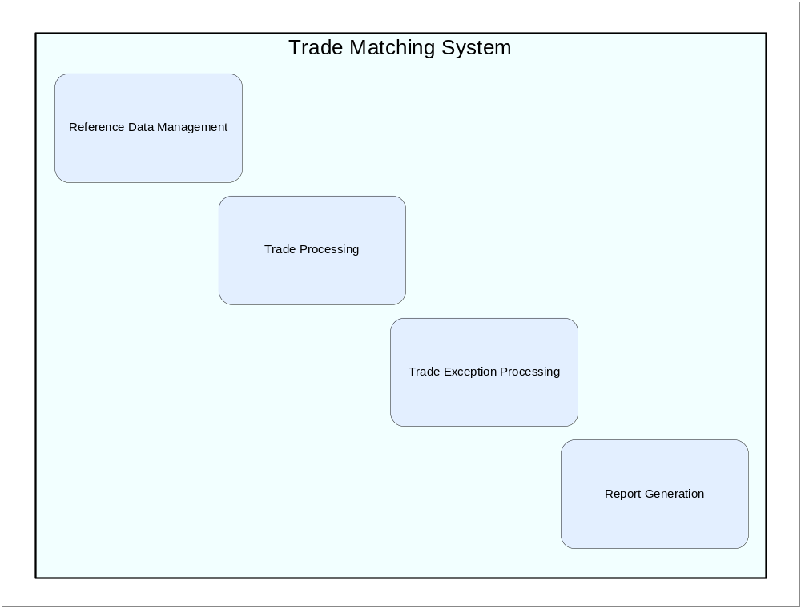

Functional View – Level Two

Reference Data Management
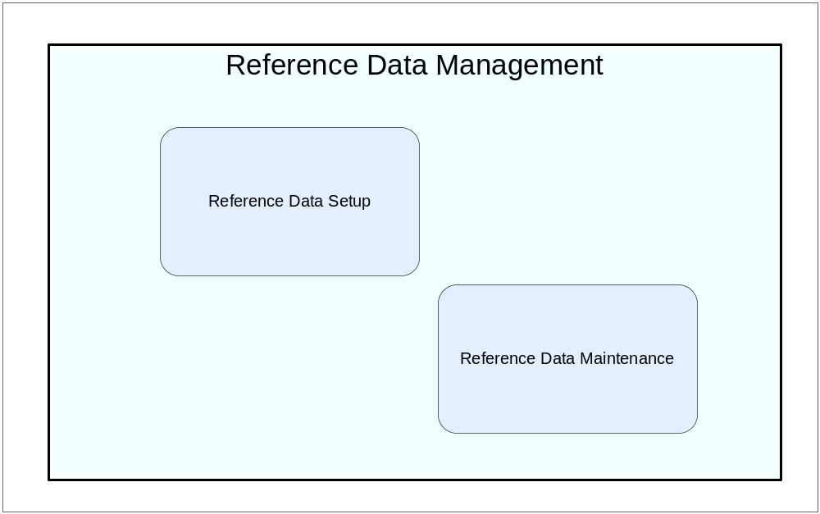

Trade Processing
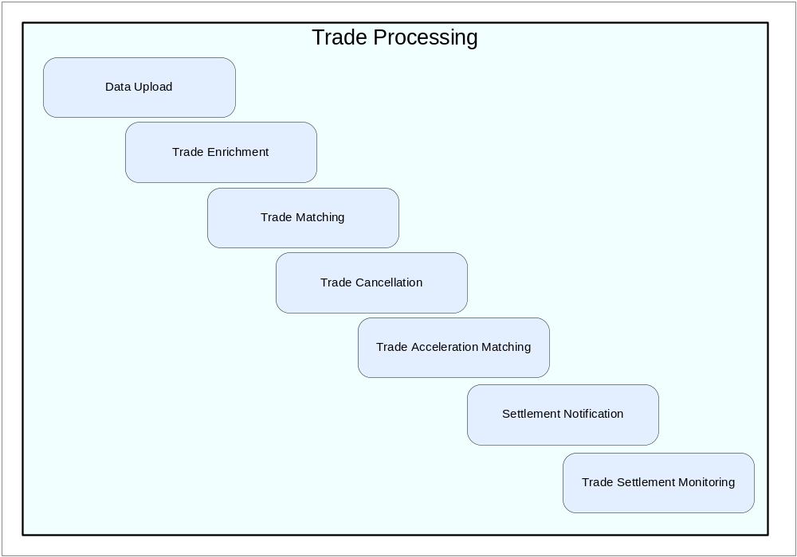

Manual Trade Processing
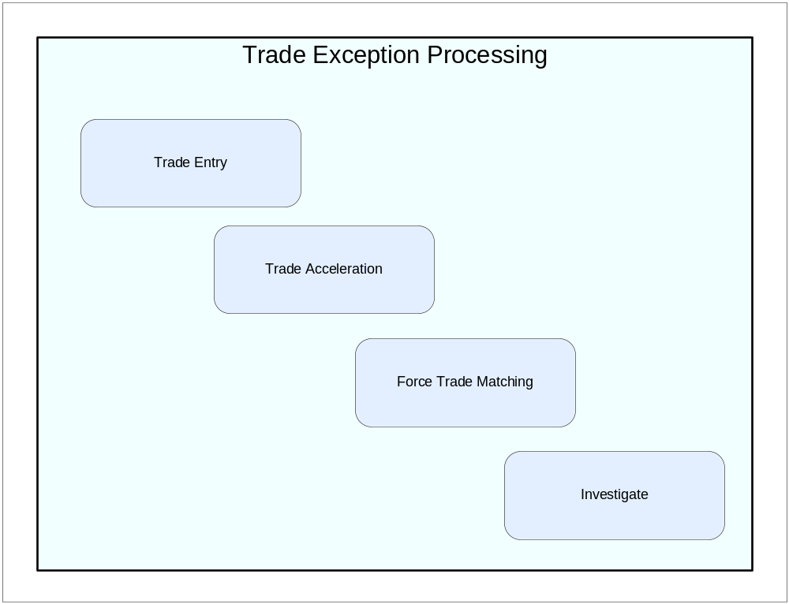

Reporting
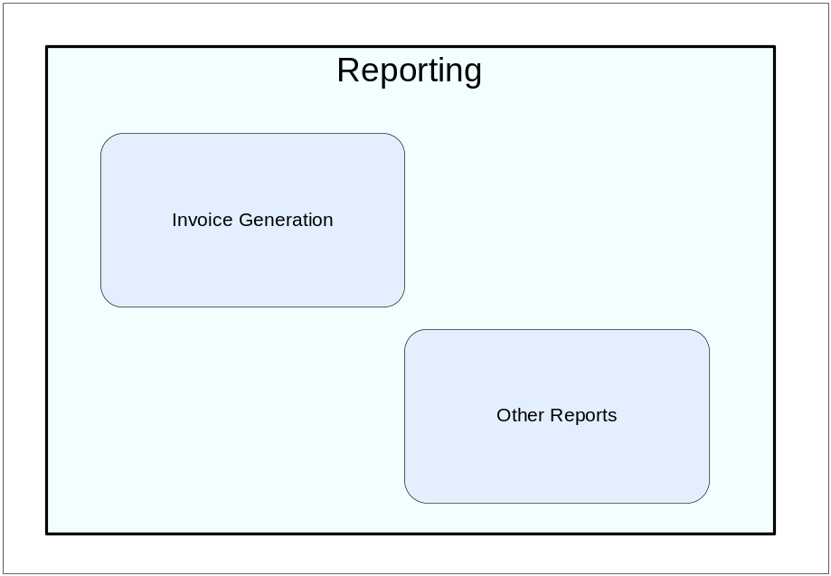

Functional View-Process Flow Map
Function | Process
Reference Data Management | Reference Data Setup
 | Reference Data Maintenance
 | Reference Data Migration
Trade Processing | Automatic Trade Upload
 | Trade Enrichment
 | Trade Matching
 | Trade Acceleration Matching
 | Trade Cancellation
 | Manual Trade Processing
 | Trade Investigate
 | Trade Force Matching
 | Trade Acceleration
 | Trade Manual Entry
Reporting | Invoice Generation
 | Other Reports
 | KPI Report
 | Transaction Summary Report
 | Transaction Detail Report
 | Trade Exception Report

Functional Interaction Diagram
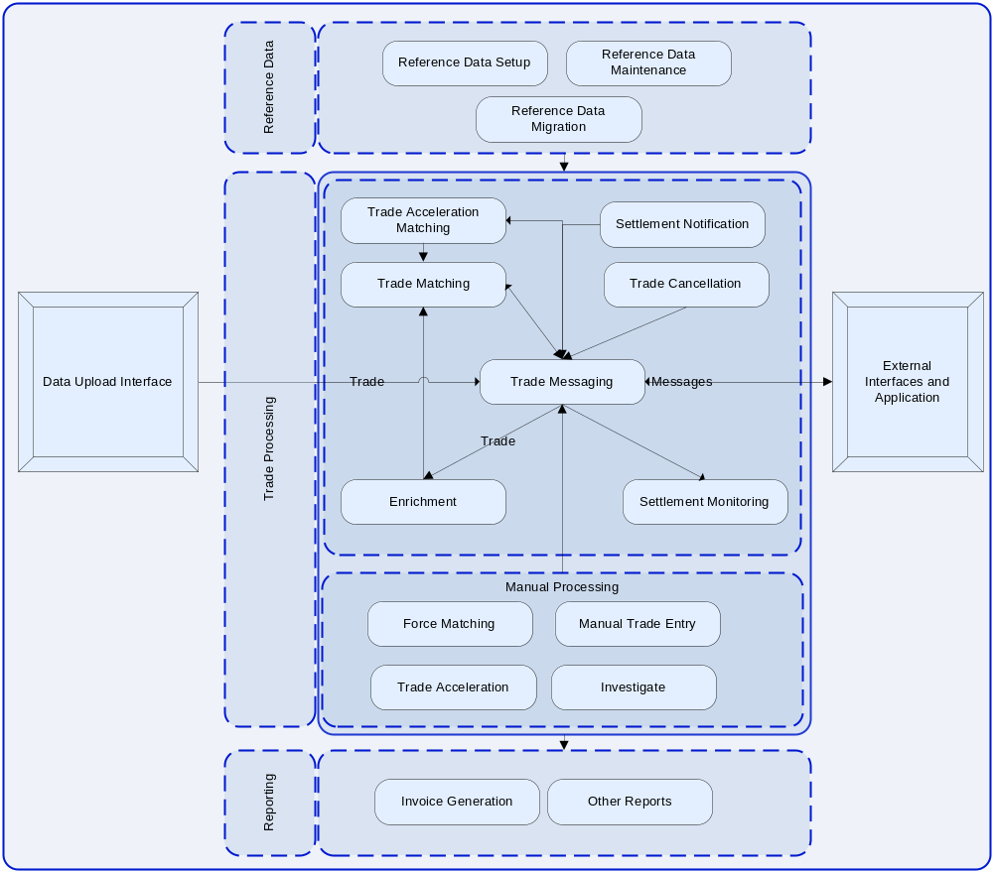

Entity Relationship View
An entity-relationship diagram is a data modeling technique that creates a graphical representation of the entities, and the relationships between entities, within an information system.
Three main components of Entity Relationship Diagram
Entity – A person, place or thing about which we want to collect and store multiple instances of data. It has a name, which is a noun, and attributes which describe the data we are interested in storing. It also has an identifier, which uniquely identifies one instance of an entity. The attribute which acts as the identifier is marked with an asterisk.
Relationship – Illustrates an association between two entities. It has a name which is a verb. It also has cardinality and modality.
Cardinality and Modality are the indicators of the business rules around a relationship. Cardinality refers to the maximum number of times an instance in one entity can be associated with instances in the related entity. Modality refers to the minimum number of times an instance in one entity can be associated with an instance in the related entity. Cardinality can be 1 or many and the symbol is placed on the outside ends of the relationship line, closest to the entity, Modality can be 1 or 0 and the symbol is placed on the inside, next to the cardinality symbol. For a cardinality of 1 a straight line is drawn. For a cardinality of many, a foot with three toes is drawn. For a modality of 1 a straight line is drawn. For a modality of 0 a circle is drawn.
Note: Please refer ER Sample file in appendix for further details
Notations Used
Notations | Description of Notation
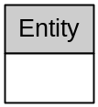 | Entity (Attribute list can be provided optionally)
 | Modality / Cardinality: zero or more
 | Modality / Cardinality: 1 or more
 | Modality / Cardinality: zero or 1
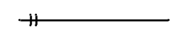 | Modality / Cardinality: One and only one

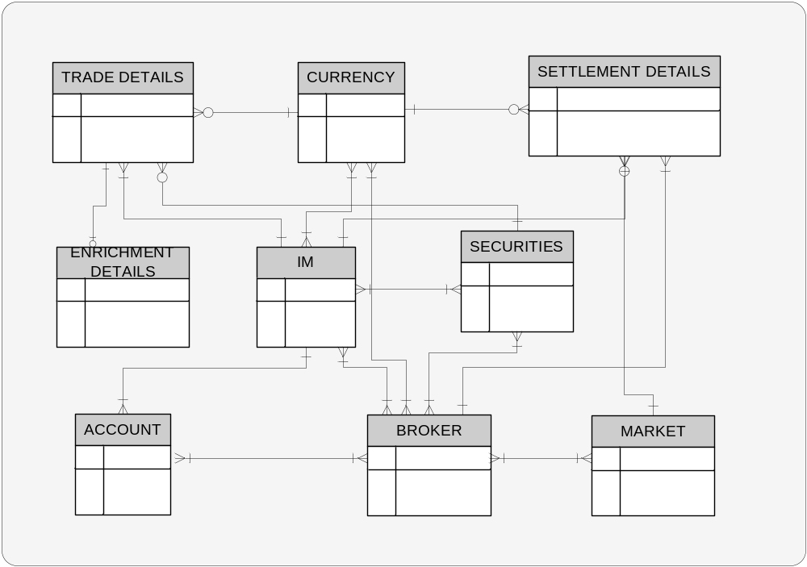

Entities Description
Entity Name | Description
Investment Manager | Represents information about investment managers
Broker | Represents information about broker
Account | Represents information about clients of the investment managers
Currency | Represents information about currency used in trading
Trade Details | Represents trade information forwarded by brokers and investment managers
Settlement Details | Represents settlement trade information
Securities | Represents information about securities that can be traded
Market | Represents information about markets in which trading is permitted
Enrichment Details | Represents information required for enriching a trade

Data View

Data Entities and Attributes of Conceptual Model
Entity/Attribute | Description | Type | Mandatory/Optional
Securities Data
ISIN | International Securities Identification Number – Prime identifier for transaction matching | Alphanumeric | Y
SEDOL | Stock Exchange Daily Official List - Secondary identifier for transaction matching | Alphanumeric | Y
CUSIP | Committee on Uniform Securities Identification Procedure – Tertiary identifier for transaction matching | Alphanumeric | Y
Security Type Code | System level unique identifier for security | Alphanumeric | Y
Currency Code | Code for the preferred currency for settlement processing | Alphanumeric | Y
Country of Issue | The name of the country in which the stock is issued | Alphanumeric | Y
Securities Description | The name of the security | Alphanumeric | Y
Client Securities Identification | Market standard identifier or IM identifier for the security | Alphanumeric | Y
Broker Data
Broker Code | Unique identification code for the broker in the trade matching system | Alphanumeric | Y
Broker Name | Broker Name | Alphanumeric | Y
Broker Identification Code – External | Broker identification in any of the external system which interfaces with trade matching system | Alphanumeric | N
Account Details
Account code | Unique code which identifies an account | Alphanumeric | Y
Manager Identifier | Code identifying which IM this account belongs to | Alphanumeric | Y
Manager’s Account Reference | IM’s unique code for the account | Alphanumeric | Y
Counter Party Account Reference | Account reference quoted for brokers or other counter parties | Alphanumeric | Y
Custodian Account Reference Number | Custodian’s safe keeping account number | Alphanumeric | Y
Currency Details
Currency Code | Unique identifier of currency in the system | Alphanumeric | Y
ISO Currency Code | Market standard currency identifier | Alphanumeric | Y
Currency Name | Name of the currency | Alphanumeric | Y
Number of decimals | Number of decimal places allowed for this currency | Alphanumeric | Y
Trade Details
Sender Reference ID | Client transaction reference | Alphanumeric
Transaction Type | Receipt free of payment, delivery free of payment, receipt on delivery, payment on delivery | Alphanumeric | Y
Cancellation Indicator | Cancellation of trade will be identified by cancellation indicator | Alphanumeric | Y
Original Transaction Reference | To identify the original transaction to be cancelled. This is the link used for canceling a trade | Alphanumeric | Y
Trade Date | Date when the Security is traded | Date | Y
Settlement Date | Date on which the settlement is effected. | Date | Y
Securities Identification Type | Whether the identification number is ISIN or SEDOL etc. | Alphanumeric | Y
Securities Identification Number | ISIN or SEDOL or CUSIP number | Alphanumeric | Y
Securities Type | Bond, Stock, FX, Money Market etc. | Alphanumeric | Y
Quantity of financial Instrument | The quantum of financial instruments to be settled | Number | Y
Fixed Income Issue Date | Issue date of the fixed income bond | Date | Y for Fixed income bond
Fixed Income Maturity Date | Maturity date of the fixed income bond | Date | Y for Fixed income bond
Fixed Income – Face Value | Face Amount of the original instrument | Number | Y for Fixed income bond
Coupon Rate | Coupon rate of the fixed income bond | Number | Y for Fixed income bond
Buy Currency | Currency bought during a FX transaction | ISO Country code | Y for FX
Sell Currency | Currency sold during a FX Transaction | ISO Country code | Y for FX
Exchange Rate | Exchange Rate during FX transaction | Number | Y for FX
Money Market type | Fixed Loan/ Fixed Deposit or Call Loan / Call Deposit indicating the type of MM transaction | Alphanumeric | Y for Money markets
Maturity Date | Maturity Date money market instrument | Date | Y for Money markets
Period of Notice | Period Of Notice call loan / deposit | Number | Y for Money markets
Deal Type | Indicates if the deal is with a third party or custodian | Alphanumeric | Y for FX and MM
Option Style | Option style (American Options, European or Asian) for Option Trades | Alphanumeric | Y for Options
Option type | Option type (Call or Put) for Options | Alphanumeric | Y for Options
Expire Date | Date on which the option will expire | Date | Y for Options and Futures
Strike Price | Exercise price for option securities | Number | Y for Options
Covered Call Indicator | Determines if the option is covered or naked | Alphanumeric | Optional for Options
Underlying Shares | Underlying shares per contract | Alphanumeric | Optional for Options and Futures
Settlement Details
Safe Hold Depository Address | BIC address of the depository where securities are held | Alphanumeric | Y
Settlement Depository Address | BIC address of the depository where securities are to be settled | Alphanumeric | Y
Broker Delivery Instructions | Set of settlement instruction | Alphanumeric | Y
Deal Price | Price of unit of an instrument | Number | Mandatory for securities
Principal Amount | The deal amount not including taxes and charges | Number | Mandatory for securities
Net Cash Amount | The net deal amount (inclusive of taxes) | Number | Mandatory for securities
Deal currency | Currency in which the trade is made | Alphanumeric | Mandatory for securities
Settlement Currency | Currency in which the settlement is made | Alphanumeric | Mandatory for securities
Buy Amount | The gross buy amount for FX | Number | Mandatory for FX
Sell Amount | The gross sell amount for FX | Number | Mandatory for FX
Exchange Rate | The rate of exchange between buy currency and sell currency | Number | Mandatory for FX
Buy Currency | The currency which is bought in the trade | Alphanumeric | Mandatory for FX
Sell Currency | The currency which is sold in the trade | Alphanumeric | Mandatory for FX
Broker Commission | Commission amount to be paid to broker for handling the trade | Alphanumeric | N
Taxes | Tax applicable for the transaction | Number | N
Fees (Local and Other) | Fees and charges applicable for the transaction | Number | N
Market
ISO Country Code | The unique country code | Alphanumeric | Y
Place of Settlement | An 8 or 11 character BIC value | Alphanumeric | Y
Enrichment Details
Security ID | The unique securities identifier | Alphanumeric | Y
Broker BIC | Broker unique identification number | Alphanumeric | Y
Market Charges | Charges applicable for the trade | Alphanumeric | Y
Settle Broker | Settlement broker detail | Alphanumeric | Y
Safekeeping Account | Custodian details | Alphanumeric | Y
Clearing System | The clearing system to be used for clearing the trade | Alphanumeric | Y
Dealing Broker | Detail of the broker who executed the deal | Alphanumeric | Y

System View
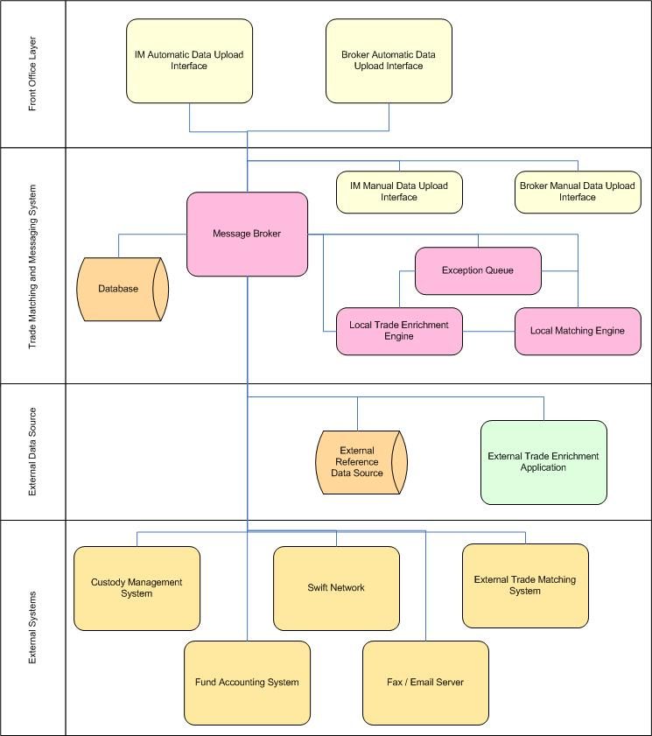

Appendix

Appendix–1: References
Securities Services – IMOS Business IT Model

Appendix–2: Definitions
SECURITIES IDENTIFIER | Security identifier types are the various methods by which a security product or issue is identified. They are each managed and distributed by different organizations
ISIN | International Securities Identifying Number (ISIN) uniquely identifies a security. Its structure is defined in ISO 6166. Securities for which ISINs are issued include bonds, commercial paper, equities and warrants. The ISIN code is a 12-character alpha-numerical code that does not contain information characterizing financial instruments but serves for uniform identification of a security at trading and settlement.  Securities with which ISINs can be used include debt securities, shares, options, derivatives and futures. Additionally, securities offered on more than one stock exchange will use the same ISIN, which can make it problematic when trading in Europe where this is common. For instance, DaimlerChrysler stock trades on twenty-two different stock exchanges worldwide, and is priced in five different currencies. ISIN cannot specify a particular trade in this case, and another identifier, typically the three-letter exchange code, will have to be specified in addition to the ISIN.  ISINs consist of three parts: a two letter country code, a nine character alpha-numeric national security identifier, and a single check digit. The country code is the ISO 3166-1 alpha-2 code for the country of issue, which is not necessarily the country in which the issuing company is domiciled. International securities cleared through Clearstream or Euroclear, which are Europe-wide, use "XS" as the country code.  The nine-digit security identifier is the National Securities Identifying Number, or NSIN, assigned by governing bodies in each country, known as the national numbering agency (NNA). In North America the NNA is the CUSIP organization, meaning that CUSIPs can easily be converted into ISINs by adding the US or CA country code to the beginning of the existing CUSIP code and adding an additional check digit at the end. In England and Ireland the NNA is the London Stock Exchange and the NSIN is the SEDOL, converted in a similar fashion after padding the SEDOL number out with leading zeros. Most other countries use similar conversions, but if no country NNA exists then regional NNAs are used instead
SEDOL | SEDOL stands for Stock Exchange Daily Official List, a list of security identifiers used in England and Ireland for clearing purposes. The numbers are assigned by the London Stock Exchange, on request by the security issuer. SEDOL serve as the NSIN for all securities issued in the United Kingdom and are therefore part of the security's ISIN as well.  Although SEDOL was to have been superseded by ISIN, problems with the ISIN system have since forced a reversal of this decision. In particular, a single ISIN is used to identify the shares of a company no matter what exchange it is being traded on, making it impossible to specify a trade on a particular exchange or currency  SEDOLs consist of two parts, a six-place alphanumeric code and a trailing check digit. Sedols issued prior to January 26, 2004 were comprised only of numbers. For those older sedols, those from Asia typically begin with 6, and those from the UK typically begin with 0
CUSIP | The acronym CUSIP typically refers to both the Committee on Uniform Security Identification Procedures and the 9-digit alphanumeric security identifiers that they distribute for all North American securities for the purposes of facilitating clearing and settlement of trades. The CUSIP distribution system is owned by the American Bankers Association and is operated by Standard & Poor's. The CUSIP Services Bureau acts as the National Numbering Association (NNA) for North America, and the CUSIP serves as the National Securities Identification Number for products issued from both the United States and Canada
ISID | International Securities Identification Directory: The International Securities Identification Directory (ISID) is a cross reference for the many different identification schemes in use. ISID Plus seems to be an expanded version of ISID (allowing more characters in the identifier).
CINS | The CUSIP International Numbering System (CINS) is a close cousin to CUSIP. Like CUSIP, it is a 9-digit numbering scheme that is used by the US finance industry. Unlike CUSIP, the numbers are used to identify securities that are traded or issued by companies outside the US and Canada.
QUICK | A numbering system used in Japan
RIC | Reuters Identification Code, used within the Reuters system to identify instruments worldwide. Contains an X character market specific code (can be the CUSIP or EPIC codes) followed by .YY where YY stand for the two digit country code. I.e. IBM in UK would be IBM.UK. More information is available at http://www.reuters.com
SICOVAM | A 5-digit code allocated to French securities (Socie'te' Interprofessionelle pour la Compensation des Valeurs Mobili`eres).

Appendix–3: SWIFT Messages applicable for trade matching and messaging
Message Code | Message Type | Purpose
Category of Message: Financial Institution Transfer
MT 202 | General Financial Institution Transfer | Requests the movement of funds between financial  Institutions
MT 210 | Notice to Receive | Notifies the Receiver that it will receive funds for the Sender’s account
Category of Message: Treasury Markets - Foreign Exchange, Money Markets and Derivatives
MT 300 | Foreign Exchange Confirmation | Confirms information agreed to in the buying/selling of two currencies
MT 320 | Fixed Loan/Deposit Confirmation | Confirms the terms of a contract relative to a fixed  Loan/deposit transaction
MT 304 | Advice/Instruction of a Third Party Deal | Advises of or instructs settlement of a third party foreign exchange deal
MT 321 | Instruction to Settle a Third Party Loan/Deposit | Advises the trade details and instructs the settlement of a fixed term loan/deposit done with a third party financial institution
Category of Message: Securities Markets
MT 540 | Receive Free | Instructs a receipt of financial instruments free of payment. It may also be used to request a cancellation or pre-advise an instruction
MT 541 | Receive Against Payment | Instructs a receipt of financial instruments against payment. It may also be used to request a cancellation or pre-advise an instruction
MT 542 | Deliver Free | Instructs a delivery of financial instruments free of payment. It may also be used to request a cancellation or pre-advise an instruction
MT 543 | Deliver Against Payment | Instructs a delivery of financial instruments against payment. It may also be used to request a cancellation or pre-advise an instruction
MT598 | Proprietary Message (if no existing Message Type exists) | We are currently using it as Batch Header and Trailer for SWIFT formatted trades. I.e., it is used as an envelope for a specified message included in it

Appendix–4: Considerations for a buy vs. build decision
The following will be the key parameters to be considered in any buy vs. build decision
Parameters | Build | Buy
Flexibility | There will be more flexibility in building a software as requirements can be tailored as per need | Less flexible as what ever available as part of the product has be to accepted and scope for customization will be minimal and it will be costly and time consuming
Cost | Depends on the features build and vendor | Depends on the vendor and generally there is less control over product cost
Speed of deployment | Will take time to build and deploy | Based on the need, can be deployed in shorter time span
Control | Better control | Lesser control

For evaluating Commercial Off The Shelf Products cognizant proposes the following 12 steps approach:
- Review (or create) Primary Functional, Non-Functional and Environmental requirements.
- Create Functional Scenarios
- Review (or create) system and technology architectures
- Identify the Global set of probable vendors
- Create a comprehensive Attribute List under the three major categories of Technical, Non-Technical and Functional.
- Collect and review the ratings/responses from the vendors on the attribute list
- Feed the ratings and the metrics into COTS Evaluation tool
- On basis of the rankings select the product as shown by COTS Evaluation tool
- Create a prototype environment with the product selected above
- Check if the prototype meets the desired criteria.
- If the prototype meets all the criteria recommend the product
- If not pick up the next product on basis of ranking and perform prototyping

While these steps are generic in nature, they could be tuned to specific engagements based on the needs of the problem domain
General factors to be evaluated for any Commercial Off The Shelf Products;
- Total cost of ownership
- Scalability
- Functionality
- Ease of use
- Dependency on a support team
- Technology

Appendix–5: Sample file for ER Diagram
ER Sample File
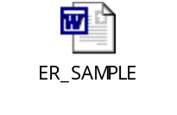

Appendix–6: Trade Communication Products
The following is the list of some of trade communication platforms that are available:
- Financial Fusion/Sybase
Product Components:
TradeForce Suite: The focus of these products is to address specific points on the STP chain and offer Integration, connectivity, and message transformation for trade initiation, execution clearing, settlement, and automation of matching process for electronic trades. Adapters include SWIFT, FIX, Omgeo, Consumer eFinance Suite, Business eFinance Suite, Corporate Cash Management Suite
Typical Implementations:
Asset Managers Utilize Financial Fusion network interconnectivity for FIX, SWIFT, and other adapters for trading integration and post-trade operations.
Custodian Banks Sybase, New Era, and Financial Fusion jointly serve a number of custodial banks with connectivity, integration, data management, and mobile solutions.
Broker/Dealers Clearing & Settlement: New Era of Networks, acquired approximately two years ago, built a large customer base in the clearing and settlement arena among broker dealers supporting STP for a variety of asset classes
- Heliograph
Product Components:
Helio TradeFlow. Providing transaction monitoring, status management, and reporting on all securities, FX, and money market trades. It offers workflow from initial order, through trade matching, to settlement. TradeFlow interfaces with trade order management systems, portfolio management packages, and links to counterparties and industry utilities such as Omgeo’s CTM.
Event. ISO15022-compliant solution for lifecycle management of corporate actions. From initial announcement capture and data cleansing through browser-based decision gathering to final reconciliation of entitlements and post event completion processes
Helio Message Broker. Messaging solution for formatting, translation, and routing. It connects disparate systems to each other or to a financial network via SWIFT adapters
ISO Converter. Low-cost, entry-level SWIFT converter that enables users to generate and parse ISO 15022 message types. It is aimed at those firms looking at using only the new ISO message formats.
Typical Implementations
Asset Managers/Custodian Banks/Broker/Dealers
Used for automating post-trade processes and corporate actions processing. Primary focus is on financial messaging standards and external connectivity to clients, agent banks, and broker/dealers
- Mercator
Product Components:
Mercator Inside Integrator components include:
Integration Broker for data translation, mapping, and routing
Business Process Management/Business Activity Monitoring graphically models and automates business processes, linking them with enterprise applications, corporate data, Internet resources, and trading partners. BAM visually exposes disparate technical and data sources that have been integrated using Mercator technology.
Commerce Management and Design Tools enable the definitions of B2B partnerships, routing rules, and communications options. Users can view, monitor, audit, and control the B2B integration environment across the extended enterprise, with secure data exchange with back-end systems-using technologies like XML, EDI, and Web services.
Mercator Inside solutions for Financial Services includes a number of adapter sets that target many aspects of financial messaging. This includes Mercator InsideSWIFT, InsideSTP, InsidePayments, and InsideFSManager. Libraries include standardized messaging protocols such as FIX, Omgeo, and SWIFT, adapter to payment clearing systems, and central securities depositories
Mercator InsideGemini is a matching engine that compares electronic business messages, including trade confirmations, executions, payments, orders, statements, and instructions.
Typical Implementations
Asset Managers/Custodian Banks/Broker/Dealers
The integration broker can typically be used as a point-to-point alternative for connecting internal applications or as a transactional hub. Of the 300-odd financial services customers, 150 are SWIFT users. Mercator also supports one of the largest proportions of CREST and OASYS customer sites within the UK.
- SeeBeyond
Product Components:
e*Gate Integrator 4.5. Integration broker that solves complex connectivity issues and enables the dynamic, guaranteed delivery of information across applications and systems to partners and customers
e*Ways. SeeBeyond offers over 70 productized adapters including connectivity to SWIFT, ERP, and CRM applications.
e*Insight Business Process Manager 4.5. Business process management and workflow solution that enables enterprise processes to be automated and streamlined across the many participating systems and people involved. e*Insight provides a view into an organization’s internal and external processes with real-time monitoring, management, process reporting, and analysis to measure success against KPIs.
e*Xchange Partner Manager 4.5. e*Xchange Partner Manager is a Web-based trading partner management and message tracking solution that accelerates the creation and maintenance of business partner relationships through trading partner profile management, secure connectivity, and B2B protocol support.
e*Index Global Identifier 4.5. e*Index Global Identifier is a cross-indexing solution that delivers a single customer view through real-time, automated person matching across disparate source systems, with management tools to ensure data quality.
e*Xpressway Integrator 4.5. e*Xpressway Integrator is a Web-based trading-partner onramp for Global
2000 business and B2B marketplaces that enable trading partner integration via partner downloaded connectivity software.
Typical Implementations:
Asset Managers Use SeeBeyond to link portfolio accounting systems, front-office trading with back-office settlement, and support infrastructures and systems. Matching utility linkages, as well as system integration to push and pull data and messages to and from the post trading and settlement environments.
Custodian Banks Enable SWIFT messaging and translation
Broker/Dealers Internal and inter firm routing. Have ISO15022 capabilities and message transformation, and facilitate messaging and data to brokerage processing and client facing systems
- SmartStream
Product Components
TLM® Trade Process Manager provides packaged, pre-configured, standard processing models for all of the major business processes associated with transaction processing, e.g. trade capture, validation and enrichment, confirmation and settlement, exception management, client input / repair / authorization / reporting (via Thin Web Client), matching (ETC / VMU) and Messaging (SWIFT / FIX etc).
TLM® Trade Process Manager comes with a series of pre-configured rules, states, libraries and process flows designed to support the transaction lifecycle of a Broker Dealer, Custodian and Investment Manager.
Pre configured process flows provide a starting point for business process modeling, enabling financial institutions to avoid the time and expense associated with building process models from scratch.
Typical Implementations
Asset Managers/Custodian Banks/Broker/Dealers
Covers the complete transaction lifecycle of the Broker dealer, custodian and asset manager.
- SunGard Business Integration
Product Components
MINT Knowledge Broker supports secure messaging between disparate internal and external systems; monitors and controls connections; and provides an audit trail, message repair, and automated event scheduling.
MINT Knowledge Manager is a graphical user interface used to define rules for intelligent message transformation, reformatting, and routing
MINT Knowledge Master is SunGard’s BPM tool where business professionals can visually model and implement process definitions to bridge the gap between proprietary, industry, and vendor data standards. Knowledge Master also supports business activity monitoring.
MINT Post Trade Solutions includes adapters to connect with Omgeo’s CTM, Oasys (Domestic, Global and Direct). Support for SWIFT messaging includes ISO15022 and trade-level business logic.
MINT Global SWIFT Interface Solutions (GSI) financial institutions to replace their end-of-life products with a consolidated multihub SWIFT message-processing infrastructure. SunGard FIX Engine (formerly the MINT FIX Engine).
Typical Implementations
Asset Managers/Custodian Banks/Broker/Dealers
SWIFT connectivity (service bureau available as well), STP, BPM, post-trade middle-office, operations consolidation for external connectivity
- Vitria
Product Components
Vitria BusinessWare is an EAI/B2Bi/BPM/Web services integration stack for messaging, connectivity (adapters), transformation, business process automation, workflow, graphical process monitoring/analysis, and business vocabulary management for integration both inside and outside the firewall. BusinessWare is “transport-independent” and deployable on any number of messaging infrastructures, such as IBM’s MQ and
Java Messaging Service (JMS) message buses. Vitria configures BusinessWare for a number of vertical application including the following targeted for financial services.
Accenture STP Integration Platform, powered by Vitria. A jointly developed product to be comarketed and sold with Accenture, this solution provides end-to-end transaction processing for broker/dealers and asset managers for greater business visibility.
SafeGuard. Provides financial institutions with an antiterrorist financing and anti-money laundering solution, meeting federal compliance requirements and managing the compliance process through integration, real-time monitoring, and pattern recognition across the enterprise, as well as automated processing, exception handling, and reporting.
SWIFTComplete. Allows banks and brokerages to automatically generate SWIFT compliant messages, convert between formats, and repair trades that are rejected from automated processing.
Typical Implementations
Asset Managers/Custodian Banks/Broker/Dealers
In financial services, the most common scenario for use of Vitria BusinessWare is typically implemented for internal integration. This includes operations department of institutional broker/dealers for application integration and monitoring key performance indices.
- WebMethods
Product Components
The webMethods integration platform is made up of components that are used to design, execute, and manage integration solutions. Components fall into three basic categories: run-time components, design-time components, and administrative components.
Run-Time components execute integration solutions developed by client: webMethods Integration Server, webMethods Broker, webMethods Adapters, webMethods Mainframe, webMethods Trading Networks, webMethods eStandard Modules, and webMethods Workflow
Design Time components provide tools for development and testing: webMethods Modeler, webMethods
Workflow Designer, webMethods Developer
Administrative and Monitoring tools are used to configure run-time environment and monitor execution:
webMethods Administrator, webMethods Monitor, webMethods Manager
Typical Implementations
Asset Managers/Custodian Banks/Broker/Dealers
Enable connections between investment managers, custodian banks, and broker/dealers to communicate securities transactions, both pre- and post-trade. STP, CRM integration, single customer view, cross product selling, channel integration, and reference data integration

